cte 101 video promotional toolkit | Help us spread the word!  We are excited about our new CTE 101 Video. This toolkit we give you everything you need to help us get the word out.  Windows User

CTE 101 Video Promotion Toolkit
The sample social media posts, email language and talking points below can be modified as appropriate to help share Advance CTE’s video CTE 101.
Getting Started: Follow Advance CTE on Twitter, Facebook and LinkedIn using the links below:
Twitter: @CTEWorks
Facebook: /AdvanceCTE
Use the below hashtags with your posts to help us to find them and share with our audience.
#CTEWORKS #CTE101

Here is the link to the video on our website: https://careertech.org/campaign-video

Sample Facebook/LinkedIn Post

Note: You can tag us by using the @CTEWorks. This will allow us to be notified when you shared the post.

Advance CTE’s newest video provides an overview of how Career Technical Education (CTE) prepares learners for their futures while closing the skills gap for employers across the country. Use this video with critical stakeholders, from families to employers, to continue to combat false perceptions of what CTE is and who it is for. This video is designed to help you make the case for CTE in your community and demonstrate the many benefits of today's CTE! We hope that you will watch and share! https://careertech.org/campaign-video

Sample Posts for Twitter
- #CTE learners and their parents are three times as likely to say they are “very satisfied” with the ability to learn real-world skills as part of their education as compared to non-CTE learners and their parents. Watch this #CTE101 Video via @CTEWorks to learn more! https://careertech.org/campaign-video
- Make the case for #CTE with @CTEWorks new CTE 101 video https://careertech.org/campaign-video
- Learn how Career Technical Education prepares learners for their futures while closing the skills gap for employers across the country. https://careertech.org/campaign-video #CTE #CTEWorks
- Did you know over 75% of #CTE learners enroll in postsecondary education after high school? Watch this video by @CTEWorks to learn more https://careertech.org/campaign-video #CTEWorks #CTE101
- #CTE learners have a higher graduation rate than non-CTE students. Watch this #CTE101 video by @CTEWorks to learn more https://careertech.org/campaign-video . #CTEWorks
- Did you know 89% of parents think students should receive more education about career choices while in high school? Watch this #CTE101 video by @CTEWorks to learn more. https://careertech.org/campaign-video
- Six of the ten hardest-to-fill positions are in technical fields or require a #CTE background. Watch this #CTE101 video by @CTEWorks to learn more. https://careertech.org/campaign-video #CTEWorks
- About half of all CTE learners are enrolled in programs in leading fields such as Health Care, STEM and Information Technology. Watch this CTE101 video by @CTEWorks to learn more. https://careertech.org/campaign-video #CTEWorks
- Do you know what #CTE is? Watch this video to find out https://careertech.org/campaign-video

Sample Email Language (for use in newsletters, listserv messages, etc.)

Subject Line: Help Combat False Perceptions of Career Technical Education

Advance CTE’s newest video provides an overview of how Career Technical Education (CTE) prepares learners for their futures while closing the skills gap for employers across the country. Use this video with critical stakeholders to continue to combat false perceptions of what CTE is and who it is for. This video is designed to help you make the case for CTE in your community and demonstrate the many benefits of today's CTE! We hope that you will show your support by watching and sharing the CTE 101 video: https://careertech.org/campaign-video

Data Points
- CTE learners are their parents are three times to report that they are very satisfied with their ability to learn real world skills as compared to non-CTE learners and their parents
- Over 75% of #CTE learners enroll in postsecondary education after high school.
- CTE learners have a 10% higher high school graduation rate than non-CTE students.
- 89% of parents think students should receive more education about career choices while in high school.
- Six of the ten hardest-to-fill positions are in technical fields or require a CTE background.
- About half of all CTE learners are enrolled in programs in leading fields such as health care, STEM and information technology.
- More than twice as many CTE parents report being satisfied with internship opportunities.

Sample Tweets with Social Media Graphics

Did you know over 75% of #CTE learners enroll in postsecondary education after high school? Watch this video by @CTEWorks to learn more https://careertech.org/campaign-video #CTEWorks #CTE101

#CTE learners graduate at a higher rate than non-CTE students. Watch this #CTE101 video by @CTEWorks to learn more https://careertech.org/campaign-video #CTEWorks
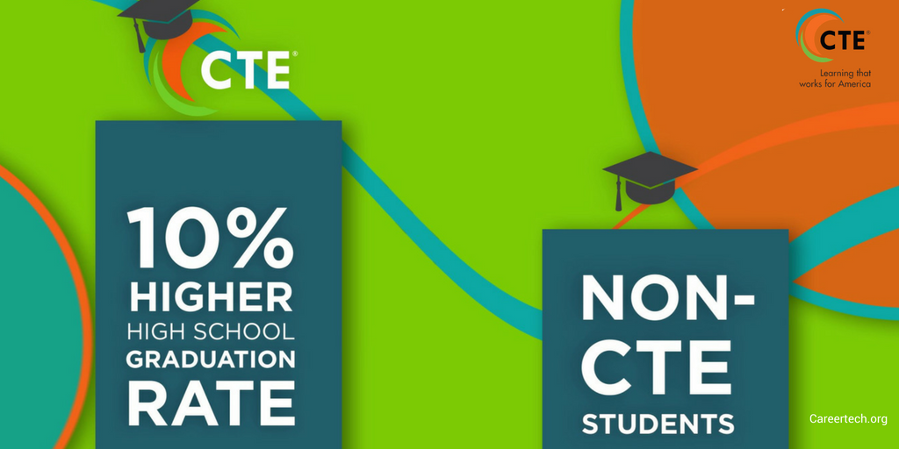

89% of parents think students should receive more #education about career choices while in high school. Watch this #CTE101 video by @CTEWorks to learn more https://careertech.org/campaign-video #CTEWorks

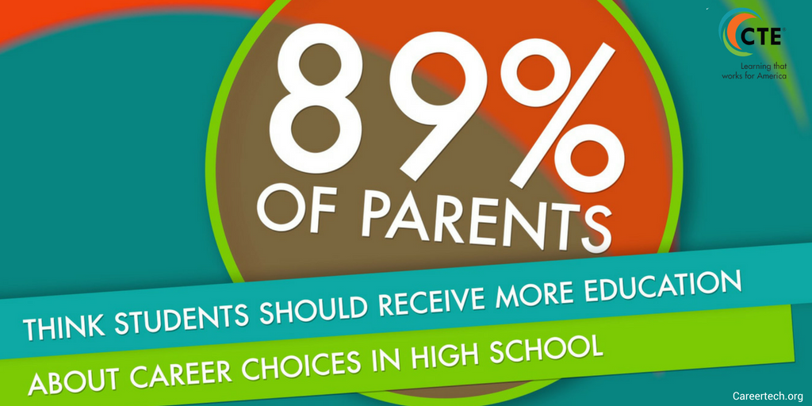

Six of the ten hardest-to-fill positions are in technical fields or require a #CTE background. Watch this #CTE101 video by @CTEWorks to learn more https://careertech.org/campaign-video #CTEWorks
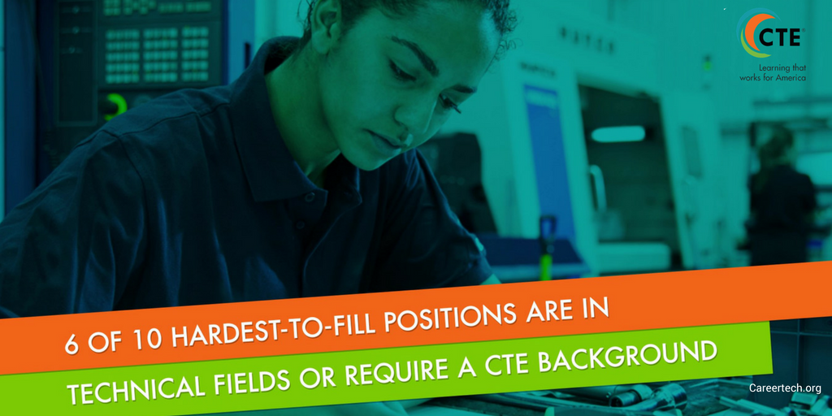
About half of all CTE learners are enrolled in programs in leading fields such as health care, STEM and information technology. Watch this #CTE101 video by @CTEWorks to learn more https://careertech.org/campaign-video
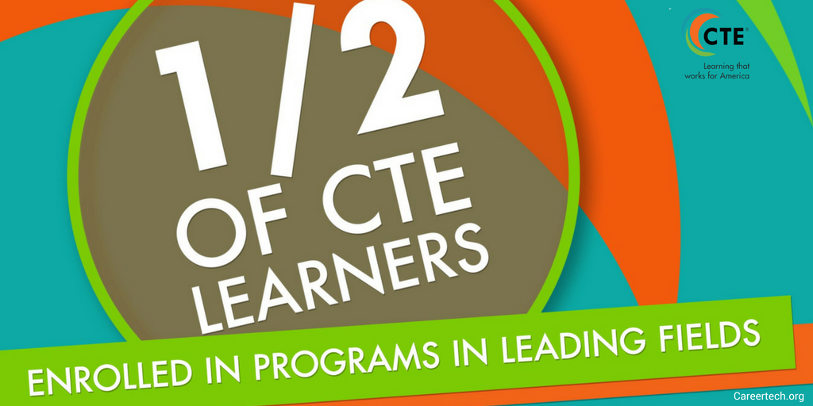

Twitter Graphics
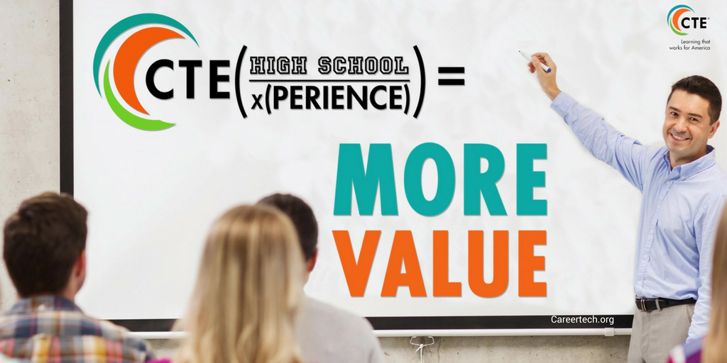
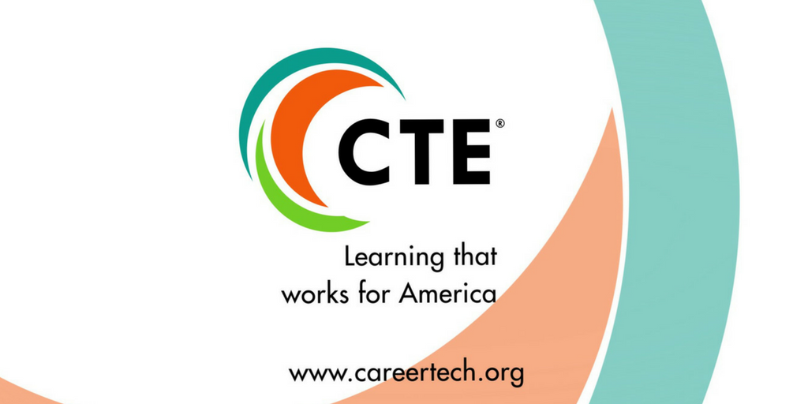
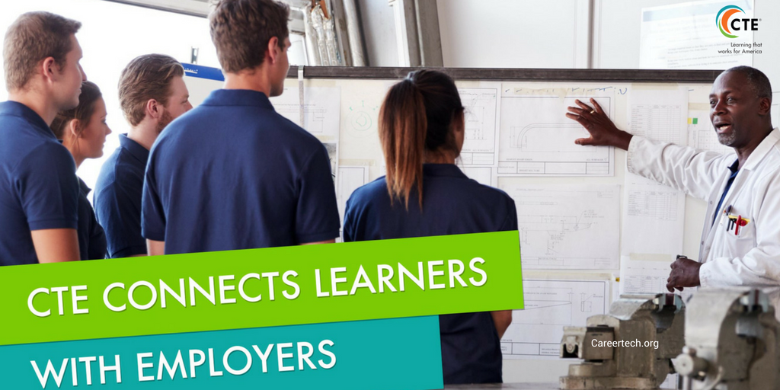

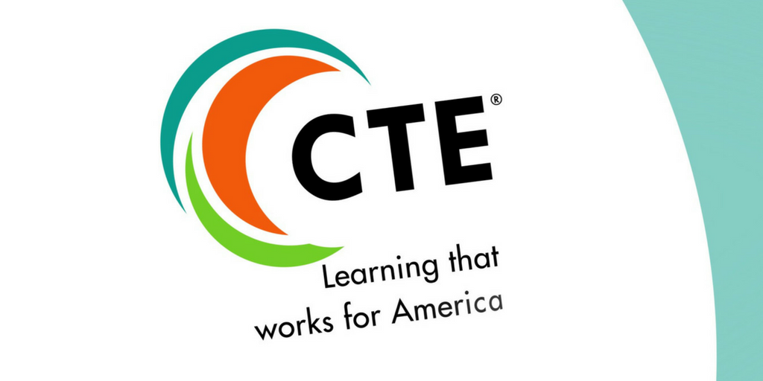
Thank you for your continued support!

