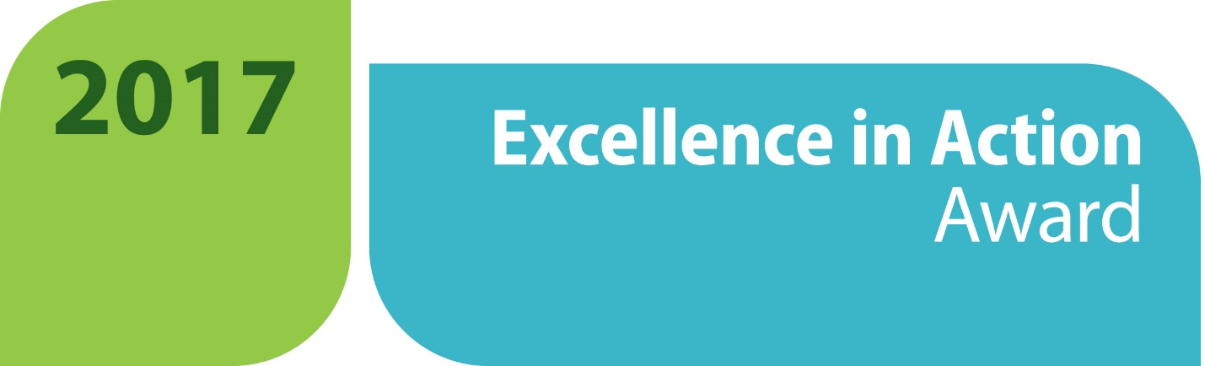
APPLICATION CHECK LIST
We want to make sure that you submit a complete application for the 2017 Excellence in Action awards, so we have provided this checklist to ensure you and your colleagues get all of your materials in before the application deadline of December 14, 2016 at 5 p.m. ET. We encourage you to read through the application in its entirety before you begin. If you have any questions or concerns, please email awards@careertech.org.
☐ I have filled out the Excellence in Action award application in its entirety while following the word limit requirements for selected questions.
☐ I have at least one letter of support from an employer or business partner.
☐ I have at least one additional letter of support from either an educational or community partner.
☐ I have included optional supplemental materials if available (photos, flyers, news articles, curriculum, etc.) and submitted as one PDF file.
☐ All materials are submitted according to the submission process outlined in the application.
☐ Celebrate! You are finished!

