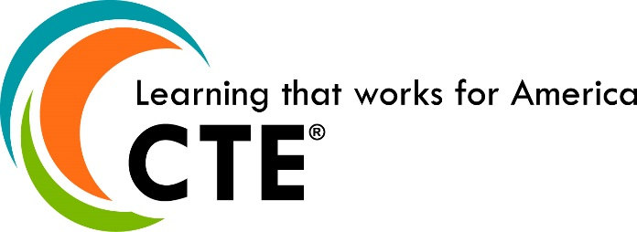

CTE BRAND PARAGRAPH
CTE (Career Technical Education) is learning that works for America. CTE is helping our nation meet the very real and immediate challenges of economic development, student achievement and global competitiveness. CTE is developing America’s most valuable resource—its people; helping them gain the skills, technical knowledge, academic foundation and real-world experience they need to prepare for high-skill, high-demand, high-wage careers—and keep America working—in every sense of the word. CTE is organized by a national framework called Career Clusters®, which presents a complete range of related career options to students of all ages, helps them discover their interests and passions, and empowers them to choose the educational pathway that can lead to success in high school, college and their chosen career. CTE is leading change, transforming expectations and making the difference for students, for high schools and colleges, for business and industry, for America. Learn more at www.careertech.org.

