|  |  |
| --- | --- |
| **Student Demographics**  **(347)** | **Percentage** |
| Male | 53% |
| Female | 47% |
| Low Income | 66% |
| Minority | 88% |
| English Language Learners | 31% |

Overview

The Academy of Finance at Como Park Senior High School in Saint Paul, MN, was launched in 2014 in close collaboration with multiple educational and employer partners to prepare learners for careers in the field of finance. A robust advisory committee provides input on the skills and competencies learners need to succeed in today’s and tomorrow’s workforce and identify work-based learning opportunities to connect classroom learning to the workplace.

A strong partnership with Saint Paul College is a key contributor to the design and implementation of the program. Learners can obtain up to 16 college credits and graduate high school with a business certificate from Saint Paul, helping them make a seamless transition to both postsecondary education and careers.

Ramsey County Workforce Solutions. The committee assisted the program staff with meeting the rigorous program of study design framework components such as partnerships, accountability systems, course sequences, credit transfer agreements and academic advisement.

Saint Paul College is a critical partner, supporting secondary and postsecondary alignment and offering learners the ability to acquire college credits. Academy learners can earn articulated credits for business/finance coursework in their sophomore and junior years and dual enrollment credits in their senior year. In 2017-18, 17 learners earned 16 college credits and a business certificate from Saint Paul College.

Developing a high-quality program of study

Originally just a business club under the National Academy Foundation, the Academy of Finance has evolved into a rigorous, high-quality program of study in which learners study accounting, international trade and leadership while preparing for further education and careers in the financial services industry. In 2014, the program received a Youth Career Connect grant from the U.S. Department of Labor to redesign the high school experience to ensure that all learners are both college and career ready.

The Business Advisory Committee consists of instructors, administrators, and key local industries and postsecondary institutions including Travelers Insurance, Hiway Federal Credit Union, Saint Paul College, Federal Reserve Bank of Minneapolis and

Como Park Senior High School

Academy of Finance *Business Management & Administration Career Cluster*

**Success by the Numbers**

Como Park Senior High School



Using feedback to continually improve the program for future Learners

The Academy of Finance has a strong commitment to meeting the needs of learners and employers, continuing to improve year after year with direct feedback from learners, staff and partners.

For example, when they started providing summer internships, employers said that learners needed stronger Microsoft Office skills. As a result, Microsoft Office was added into the curriculum, and the program now offer the Microsoft Office suite certification for learners, signaling to employers competency and skill.

To harness the learner perspective, students regularly participate in focus groups to provide feedback on their internship experiences and what should be continued or improved.

Working with partners to provide Work-Based Learning

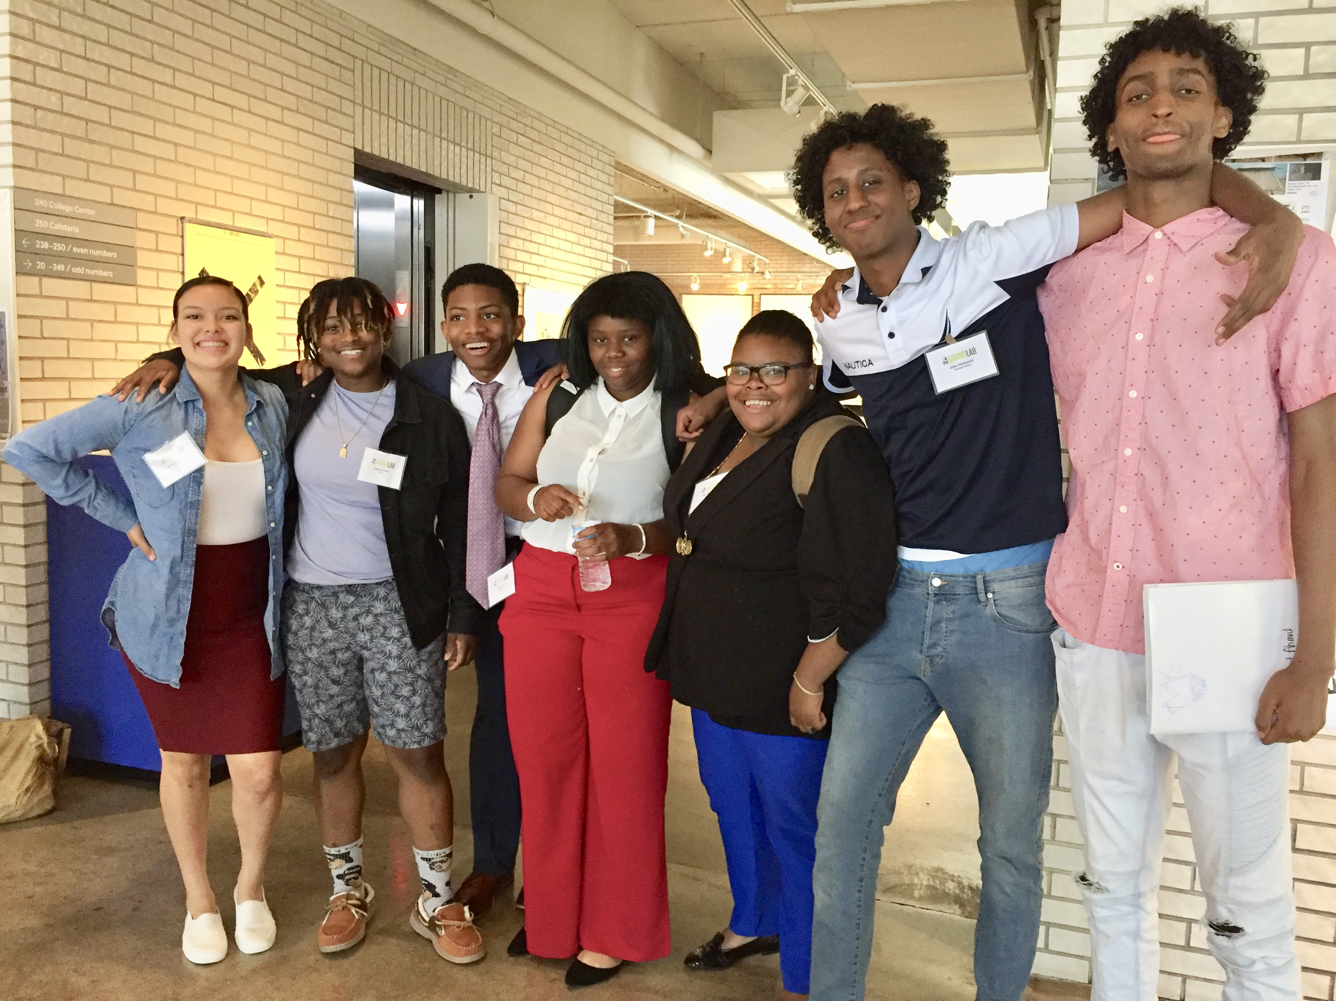  
Meaningful work-based learning is a cornerstone of the program of study. In 2017-18, 71 learners worked in paid internships, and 89 percent of learners received mentoring from business partners.

On campus, learners gain real-world skills by participating in the student-run credit union created by the Academy’s local business partner, Hiway Federal Credit Union. Learners run the branch during their lunch hours and help their peers learn about money management. Hiway Federal Credit Union staff also attend classes as guest speakers and hire learners for summer employment.

In addition, Optum Healthcare offers paid internship opportunities in which learners work in teams solve a problem identified by the company and develop a solution that is pitched to Optum leaders across the country. The employer provides lunch and transportation, ensuring that the opportunity is easily accessible for each learner. Each intern works more than 120 hours using business and information technology skills to gather data, address challenges, and present possible solutions to meet Optum’s needs.

“I am proud of the students for challenging themselves. They are exposed to rigorous college-level work, and it helps them with their self-esteem, to visualize their future and really understand their full potential.” — Hannah Chan, Academy of Finance, Program Manager, Como Park Senior High School

90%  
Participated in   
Work-Based Learning

96%  
Graduated  
High School

26%  
Earned an   
Industry-Recognized   
Credential

*Data based on 2017-18 school year*