2012 NASDCTEc Fall Meeting

AGENDA

Embassy Suites Omaha - Downtown/Old Market
555 South 10th Street, Omaha, Nebraska 68102
1-402-346-9000

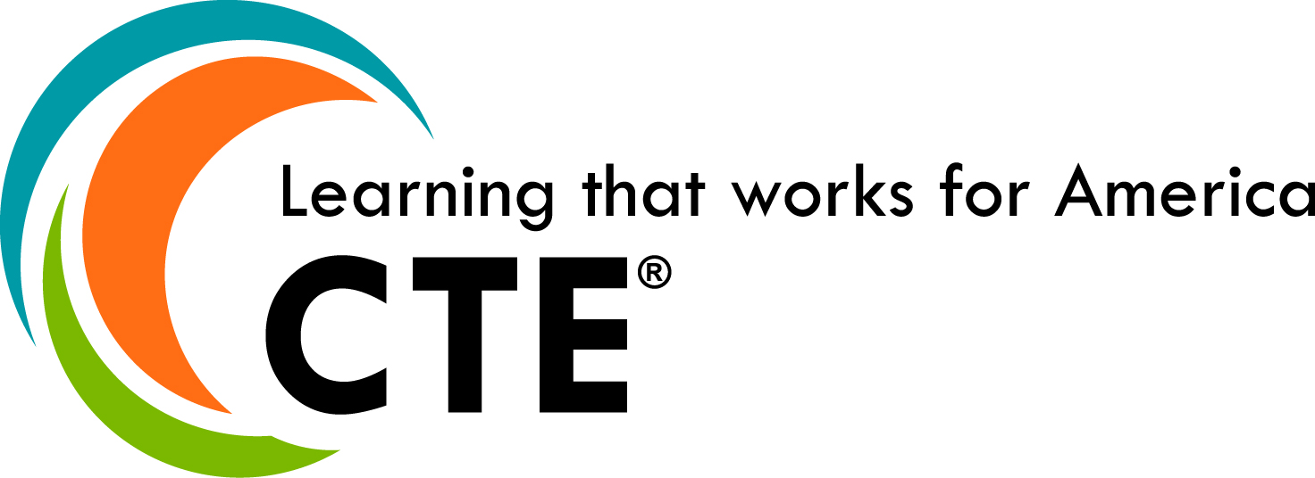

Thursday, October 11, 2012
9 a.m. - 2 p.m. NASDCTEc/NCTEF Board of Director's Meeting (Council Bluffs AB)

1 p.m. - 6:30 p.m. Registration (Registration Area)

2 p.m. - 3:45 p.m. New State Director/Leader Boot Camp (invitation only) (Big Blue A)

4 p.m. - 5 p.m. Opening General Session (Missouri/Platte)

- Swearing in of 2012-2013 NASDCTEc Officers
- Fall meeting sponsor recognition
- Progress Report on Reflect, Transform, Lead: A New Vision for Career Technical Education

5:10 p.m. - 6 p.m. Topical Breakout Sessions (Select one to attend)

CTE and AP: Opportunities and Possibilities: Wanda Monthey, Senior Director, SAT State and District Initiatives, The College Board (Elkhorn C)

CTE and the Common Core State Standards: Laura S. Roach, Oregon State Director (Elkhorn A)

Technical Skills Assessments: One State’s System: Mary Shumway, Utah State Director (Elkhorn B)

What is Career Readiness?: Pat Ainsworth, California State Director (Council Bluffs)

6:30 p.m. - 8 p.m. Dinner and Program (Missouri/Platte)

- Welcome by NASDCTEc President Marie Barry
- Remarks by Dr. Brenda Dann-Messier, Assistant Secretary, Office of Vocational and Adult Education, U.S. Department of Education
- All-Star Sponsor Recognition
- Special Presentation by Richard Hinckley, CORD

Friday, October 12, 2012

7 a.m. - 8:15 a.m. Breakfast (Embassy Suites Atrium, First Floor)

7:30 a.m. - 9 a.m. Registration

8:30 a.m. - 3:30 p.m. Executive Leadership Training provided generously by Gallup (Platte)

Session I - Policy Implications for CTE Leaders: Education Insights from Gallup: Shane Lopez, Senior Scientist and Research Director for the Clifton Strengths Institute, Gallup

Session II – Strengths-based Leadership Workshop: Great Leaders, Teams and Why People Follow: Rod Karr, Advanced Learning and Development consultant, Gallup

Networking Luncheon (Missouri)

Session III – Wellbeing: The Five Essential Elements: Tim Hodges,
Director of Research, Gallup Education Practice

3:45 p.m. - 4:45 p.m. NASDCTEc Business Meeting (open to all members) (Missouri)

Dinner on your own – hotel front desk has local restaurant information

Saturday, October 13, 2012

7 a.m. – 8:15 a.m. Breakfast (Embassy Suites Atrium, First Floor)

7:30 a.m. – 8:30 a.m. Registration

8:30 a.m. - 9:15 a.m. Applying Gallup’s Wisdom – Reflections Panel (Missouri)

Facilitator: Tim Hodges, Director of Research, Gallup’s Education Practice

Panelists: Philip Cleveland, Alabama State Director
John Fischer, Vermont State Director
Jo Anne Honeycutt, North Carolina State Director
Scott Stump, Colorado State Director

9:30 a.m. - 10:15 a.m. Round 1 of Concurrent Working Sessions

Attendees will be able to attend both sessions, each one will be repeated.

Common Career Technical Core (Missouri): Update on resources, tools and gap analysis process supporting the implementation of the CCTC. Also, Career Clusters™ activities and information about upcoming projects.

Perkins Reauthorization Dialogue Session (Platte): Defining high quality CTE programs for Perkins Reauthorization

10:30 a.m. - 11:15 a.m. Round 2 of Concurrent Working Sessions (Sessions above repeat)

11:20 a.m. -12:20 p.m. OVAE Update Session (Missouri)

Robin Utz, Branch Chief, College and Career Transitions Branch, Division of Academic and Technical Education (DATE), Office of Vocational and Adult Education (OVAE), U.S. Department of Education

12:20 p.m. - 12:30 p.m. Wrap Up of Meeting (Missouri)
Marie Barry, NASDCTEc President

