|  |  |
| --- | --- |
| **Student Demographics**  **(537)** | **Percentage** |
| Male | 14% |
| Female | 86% |
| Low Income | 46% |
| Minority | 19% |

Finally, learners in the allied health career pathway are trained in emergency preparedness. To become community emergency response team certified, learners have to complete an accident simulation, supported by partners such as the county fire department, police department, local hospitals and others. More than 200 juniors have earned this national certification over the past four years.

In addition to earning certifications that allow them to go straight from high school to the workplace, learners can transition to the Associate Degree Nursing program at Henderson Community College (HCC). Starting with the current class, HCC will reserve up to 10 spaces for SRNA learners. To be eligible, learners must pass a nursing entrance exam with 75 percent or have a composite ACT score of 20, maintain a 3.2 grade point average and attend a pre-admission conference.

Overview

The Health Science program of study launched nearly 35 years ago at Henderson County High School in Henderson, KY. The program has grown from only one career pathway with two instructors to three career pathways and five instructors, serving more than 500 learners and becoming one of the largest Career Technical Education (CTE) programs of study in the commonwealth of Kentucky.

As learners progress through the program, they can focus on one of the following areas: allied health, pre-nursing or medical administrative assistant. Regardless of their focus area, all seniors are required to participate in work-based learning experiences offered at 47 local health care facilities such as Redbanks Skilled Nursing Center, Deaconess Health System, Methodist Hospital and St. Anthony’s Hospice. Through dual credit courses, health science learners can earn up to 12 college credits, as well as five industry-recognized credentials, creating a seamless transition to both postsecondary education and careers.

preparing for college and CAREER   
  
The Health Science program is preparing learners for high-demand, high-wage professions in the health care industry. Learners in the pre-nursing career pathway can earn the state registered nurse aide (SRNA) certification their junior year, which requires them to complete 16 clinical hours in a long-term care facility. Juniors complete the clinical hours with an industry partner, Redbanks Skilled Nursing Center. The program has a 100 percent overall pass rate for the SRNA competency evaluation.

In the medical administrative assistant career pathway, learners can earn the certified medical administrative assistant certification, signaling to employers that they have the baseline skills needed to provide administrative support in a health care setting.

Henderson County High School

Health Science

*Health Sciences Career Cluster*

**Success by the Numbers**

Henderson County High School



“The Henderson County school district strives to be an innovator in education and gives us their full support. We wouldn’t be where we are today without their resources and having them work collaboratively with our CTE unit, our principal and our administration.” — Jessica Sheffer, Health Science Instructor, Henderson County High School

Reaching prospective learners and families where they are  
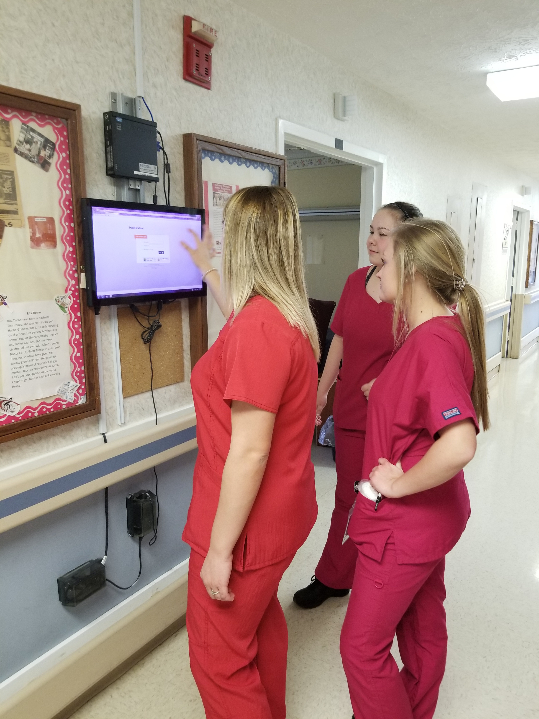

The Health Science program of study engages prospective learners and their families through in-person events such as open houses, career fairs and tours, as well as virtually. Due to a decrease in participation for open house nights, this year, Henderson County High School used video to provide a virtual tour of the program. Instructor Dana Alves describes the courses while the video shows learners participating in hands-on learning experiences, such as practicing the removal of entrapped survivors from a damage site using a leveraging technique.

The video was produced in house by the school-based enterprise called LAUNCH, a comprehensive design, marketing and IT solutions company. LAUNCH is a collaborative effort across CTE pathways including visual communications, marketing and information technology.

52%  
Earned Postsecondary   
Credit

95%  
Earned an   
Industry-Recognized   
Credential

84%  
Enrolled in   
Postsecondary  
Education

100%  
Graduated  
High School

*Data based on 2017-18 school year (seniors)*

Integrating core academics with CTE learning to develop real-world skills

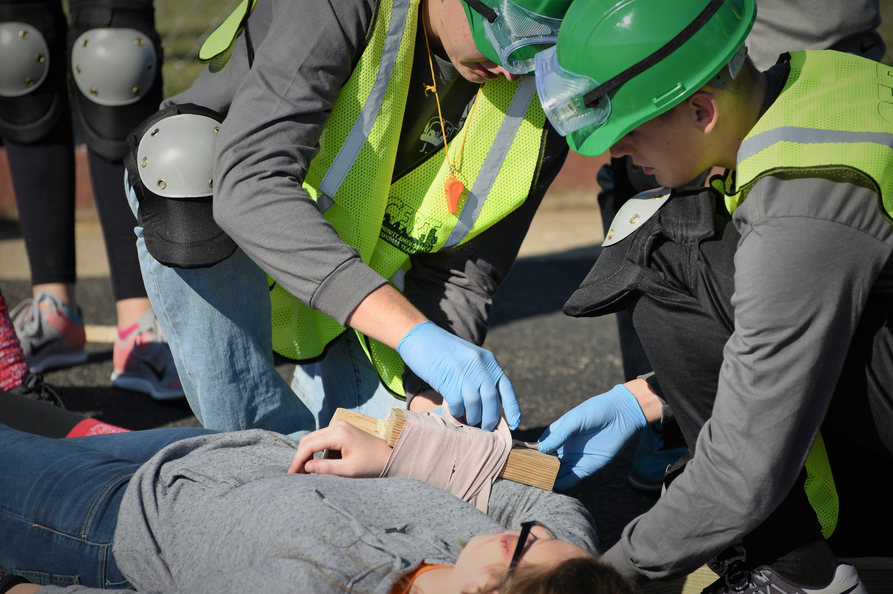  
In addition to providing work-based learning experiences, the Health Science program is equipping learners with the academic knowledge employers need. Working closely with HCC, staff were informed that incoming pre-nursing learners were having difficulty with math calculations commonly used in all health occupations. As a result, the Health Science program requires all learners to enroll in Algebra 1 before enrolling in higher-level coursework.

Further, HCC encouraged the addition of Medical Dosage Calculations — typically a college-level course — to the high school curriculum. Learners use applied techniques, problem solving and critical thinking to perform mathematical operations such as computations, ratio and proportion, weights and measurements and conversions. Through this strong partnership with HCC and a commitment to evolving to meet the needs of learners and employers, while ensuring academic rigor, the program was able to make adjustments to the program and better prepare learners for the college coursework.