|  |  |
| --- | --- |
| **Student Demographics**  **(180)** | **Percentage** |
| Male | 89% |
| Female | 11% |
| Low Income | 77% |
| Minority | 92% |
| English Language Learners | 36% |

Filling the Gap

The 2018 Boeing Pilot and Technician Outlook Report projects that worldwide 790,000 new pilots and 754,000 new maintenance technicians will be needed in the next 20 years. North America alone will require more than 200,000 pilots. The high industry demand for skilled workers has led to employers reaching out directly to schools to build a pipeline of qualified and skilled aviation technicians and airline pilots. Irving High School is located in the Dallas-Ft. Worth metro area, home to more than 300 aerospace and aviation employers and more than 400 aviation facilities including the Dallas-Ft. Worth International Airport (DFW).

Public and private partners, including North Central Texas Council of Governments, the FAA, American Airlines and Envoy, are among the 77 organizations that serve on the program advisory board to ensure that the curriculum is up to date with the latest industry trends.

These important partnerships also help to create meaningful hands-on learning experiences. For example, the Aviation Institute of Maintenance (AIM) has been a partner for the past six years. AIM operates 11 FFA-approved airframe and power plant schools throughout the country. AIM provides recommendations on curriculum and updates on FAA regulations, and it grants learners daily access to its facility and equipment.

Partnerships with educational institutions are also core to the program. Learners who successfully complete aviation courses are eligible to receive articulated credit at Spartan College. Further, students are encouraged to pursue Advanced Placement (AP) courses. The 2018-19 cohort has nearly 35 percent of learners enrolled in AP classes.

Overview

The School of Aviation at Irving High School in Irving, TX, was launched in 2012 to provide learners with rigorous academic coursework paired with the full continuum of work-based learning experiences related to the aviation industry. Learners begin with a broad understanding of aviation and aircraft technology and, in their junior year, choose a specialization — either aviation science or aviation technology — based on which career and college option is best suited for them. The program of study is anchored in the senior year with a practicum or advanced coursework requirement, which incorporates gaining real-world skills through hands-on learning experiences.

The four-year program allows learners to earn college credit through an articulation agreement with Spartan College. Additionally, the school requires learners to earn two industry-recognized credentials related to workplace safety. Learners can also earn Federal Aviation Administration (FAA) certifications to become licensed to fly drone equipment.

Irving High School

School of Aviation

*Transportation, Distribution & Logistics Career Cluster*

**Success by the Numbers**

Irving High School

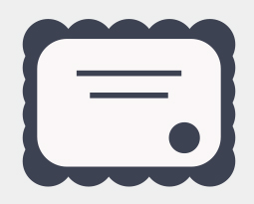

“I’m proud of the students who completed the real-world design challenge, two years in a row. Students have to use their critical thinking skills, integrate mathematics, apply scientific theory and write a 60 page paper. If they can accomplish that, they can accomplish anything. ’” — Shawn Blessing, Director of Career and Technical Education, Irving Independent School District.

94%  
Enrolled in   
Postsecondary  
Education

Creating Hands-On Learning Experiences

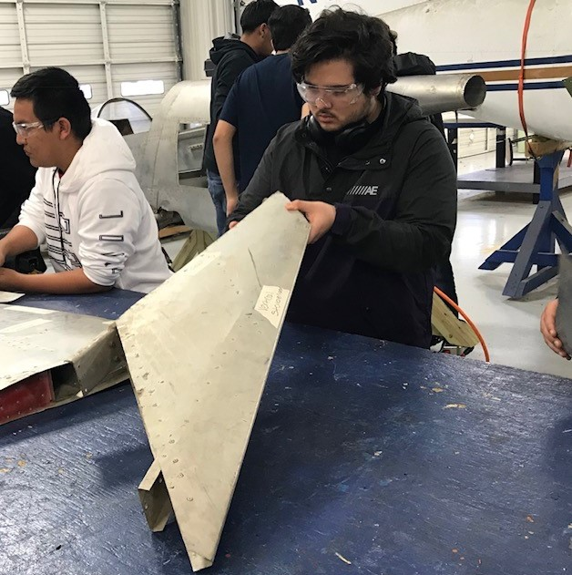  
As part of the School of Aviation program, not only are learners exposed to real-world situations through competitions and work-based learning experiences, but they also have the opportunity to get hands-on learning in the classroom. The classroom is equipped with a flight simulator, with televisions in the front of the room and a public address system connected to the simulator headsets, allowing students to see the instruments and airplane.

Since 2012, learners have participated in the Organization of Black Aerospace Professionals ACE Academy, which provides learners with exposure to careers in aviation through week-long summer camps. Learners get a behind-the-scenes look at multiple facilities, including the Grounds Operation Tower and fire facilities at DFW airport. At the conclusion of the camp, learners are offered a ride in a Cessna 172 plane.

Developing real-world skills through COMPETITIONS   
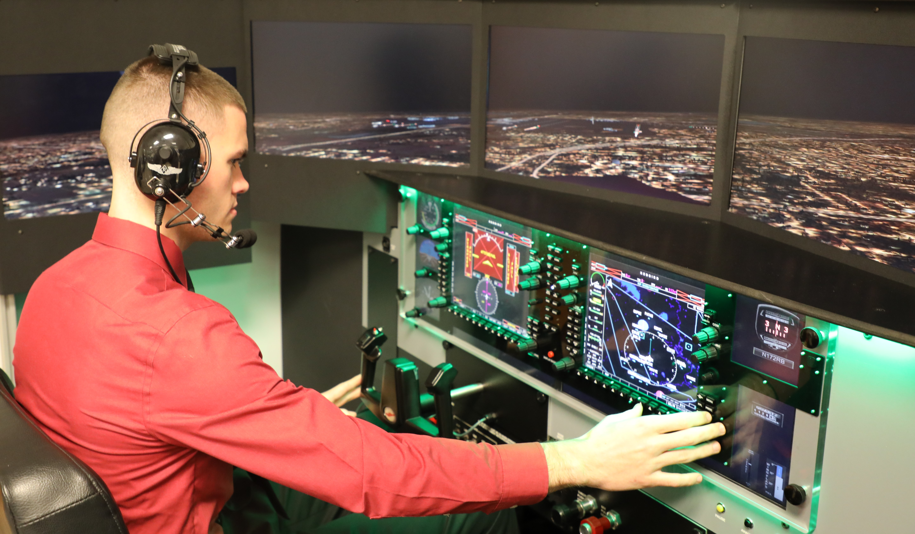The Aviation program is an active member of SkillsUSA, participating in regional, state and national competitions.

Learners have competed in the aircraft maintenance technology competition, during which they perform 12 tasks that represent the types of maintenance they will encounter in the aircraft industry.

In addition, learners compete in the annual Real World Design Challenge, during which high school learners work as a team to create solutions to engineering challenges. Learners design an unmanned aerial system or drone, using engineering software to solve the given challenge. In 2018, the team representing Irving High School won the state competition and will proceed to the national competition in April. These experiences provide learners with valuable skills such as leadership, communication and teamwork.

20%  
Earned Postsecondary   
Credit

19%  
Participated in   
Work-Based Learning

100%  
Graduated  
High School

*Data based on 2017-18 school year*

60%  
Earned an   
Industry-Recognized   
Credential