|  |  |
| --- | --- |
| **Student Demographics**  **(17)** | **Percentage** |
| Male | 95% |
| Female | 5% |
| Low Income | 16% |
| Learners With Disabilities | 5% |

high school to have access to the union’s five-year adult apprenticeship program. Now, by working with the program, learners begin training with the union their senior year of high school. The union also sponsors welding fabrication contests, supplies class materials, and contributes to the program curriculum.

Learners also participate in the Wisconsin Youth Apprenticeship program, which allows them to earn credits toward graduation requirements, receive mentored on-the-job training, get paid, and take a course on workplace safety and career development. Participants work at companies such as G&G Machine and Fox Valley Tool & Die, gaining real-world technical skills in machine programming, welding and fabrication, 3D programming/modeling and more. Completers receive a state certificate of occupational proficiency signed by the secretary of the Department of Workforce Development.

real-world industry experiences Through Youth Apprenticeships

Kaukauna is located on the Fox River, home of a manufacturing sector that has changed significantly over time. Careers that originally supported the paper mill industry have had to evolve to those that support metal working manufacturing companies. Today, the largest employers in Kaukauna are metal fabricators of pressure vessels and piping systems used in the chemical industry. As such, the Manufacturing program has had to adapt to ensure that it prepares learners with the most sought-after skills.

Businesses big and small are crucial to the program’s success. For example, Local 400 Steamfitters and Plumbers Union, a union that serves northeast Wisconsin, wanted to create a seamless way for high school learners to have a head start on their career. Previously, learners had to wait until they completed

Kaukauna High School

Manufacturing

*Manufacturing Career Cluster*

Overview

Launched in 1993 and located in Kaukauna, WI, the Manufacturing program of study at Kaukauna High School (KHS) prepares learners for high-demand careers through hands-on experiences, rigorous academic coursework and early postsecondary credit opportunities. Learners apply their academic knowledge authentically by working with, and programming, state-of-the-art machine shop equipment that uses industry-standard, computer-aided design software such as SolidWorks and AUTOCAD.

Learners can earn college credits from postsecondary partners Fox Valley Technical College (FVTC) and the University of Wisconsin Oshkosh (UWO) as well as up to two state-recognized certifications, ensuring that they leave the program with both the skills and credentials to make a smooth transition into postsecondary education or the workplace.

STEM Girls Program for Middle school learners

Efforts to increase awareness of the program have included helping change learners’ perception of manufacturing by promoting the program to the local media and inviting alumni to speak to learners.

In addition, recognizing a lack of program diversity, the head of the science department at KHS started the STEM Girls Club, which promotes female participation in fields related to science, technology, engineering and mathematics (STEM). Learners involved in the club and the Manufacturing program volunteered to organize and lead a half-day event called STEM Girls Day. Sixty-five middle school girls were in attendance to learn about STEM programs. The event included hands-on activities and a tour of the labs program learners use daily to get attendees excited about potentially enrolling in the Manufacturing program. FVTC was also a sponsor of the event.

As the Manufacturing program continues to grow and expand, it will look to learners and alumni to serve as ambassadors in an effort to create pathways into the program for non-traditional learners.

**Success by the Numbers**

Kaukauna High School



“” —

Pathway to postsecondary   
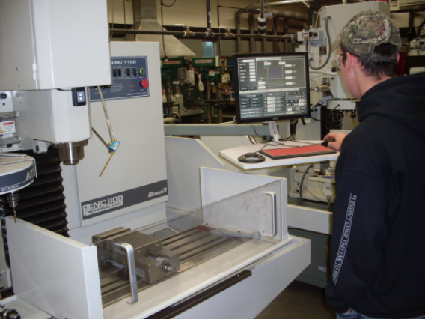  
In addition to a robust Youth Apprenticeship program, the Manufacturing program offers a pathway to postsecondary education through dual enrollment opportunities.

Learners who successfully complete courses such as Robotic Lab and Metals Technology earn credit at both KHS and FVTC. For more than 15 years, FVTC has supported the program by training program instructors, donating lab equipment and coordinating the program curriculum. To teach FVTC coursework at KHS, high school instructors must attend training during the summer, have a master’s degree in engineering, and be approved by the college.

Another partner is UWO. Learners can enroll in the Introduction to Engineering course at KHS, which follows the curriculum for the engineering degrees offered by UWO. This class is a required course for UWO engineering programs, providing a seamless pathway from secondary to postsecondary education.

100%  
Earned Postsecondary   
Credit

100%  
Participated in   
Work-Based Learning

100%  
Graduated  
High School

*Data based on 2017-18 school year*

90%  
Enrolled in   
Postsecondary  
Education