Policies & Procedures for Implementing Career Technology Student Organizations (CTSOs)

in Maryland


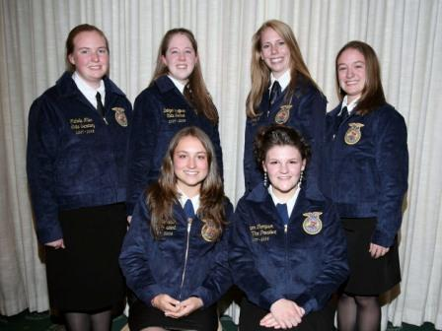
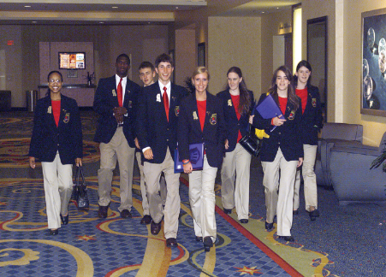
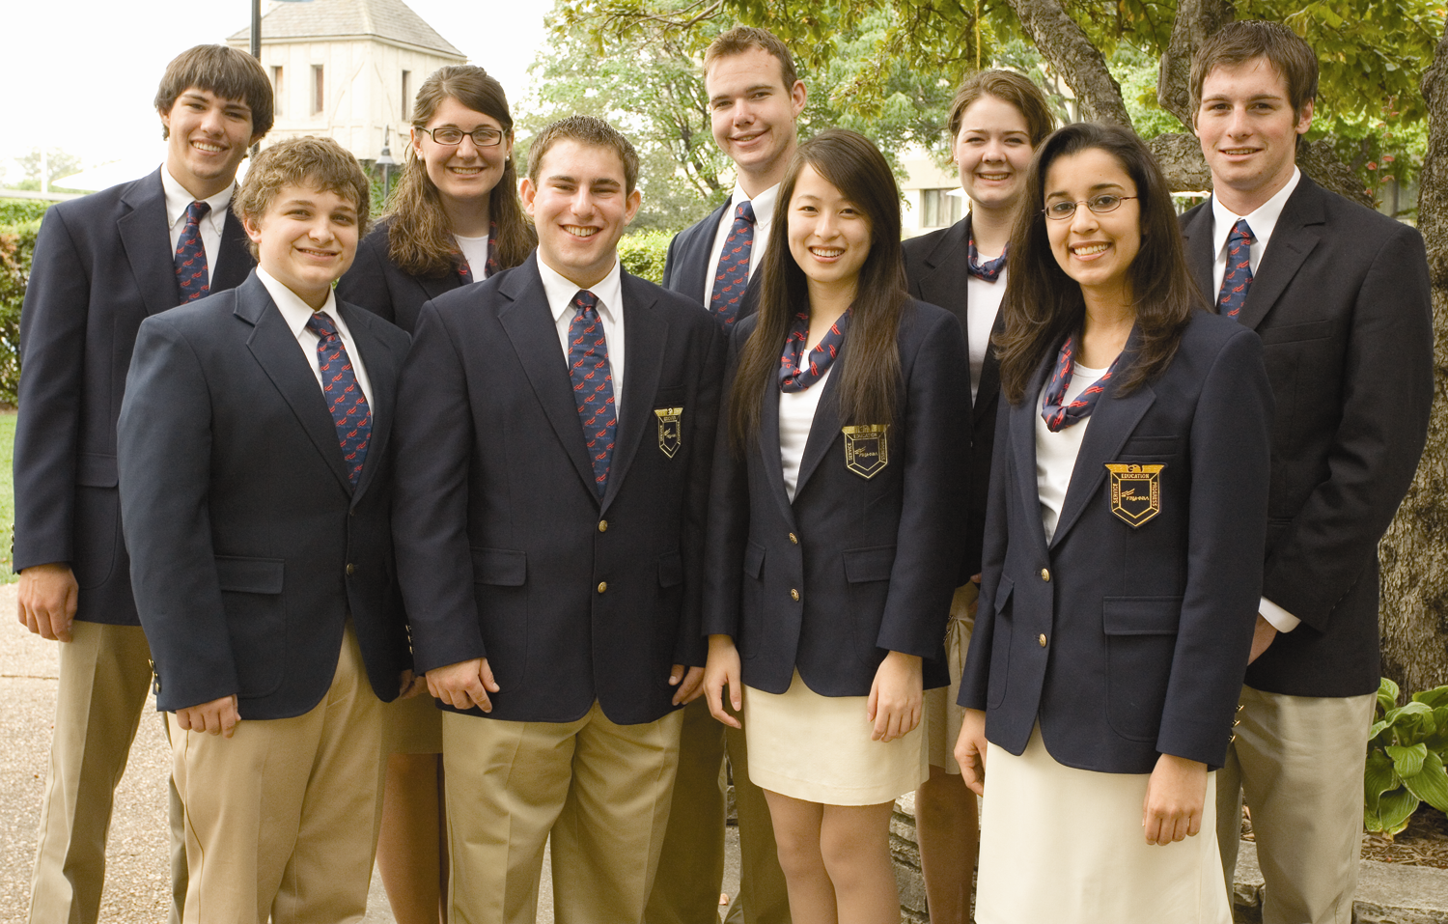
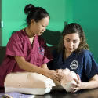

Maryland State Department of Education

Division of Career Technology and Adult Learning

June 2008

www.marylandpublicschool.org

Martin O’Malley
Governor

Maryland State Board of Education

Mr. Dunbar Brooks, President
Ms. Beverly A. Cooper, Vice President

Dr. Lelia Thompson Allen Mr. Richard L. Goodall
Mr. J. Henry Butta Dr. Karabelle A. L. Pizzigati
Dr. Charlene M. Dukes Mr. David F. Tufaro
Mr. Blair G. Ewing Ms. Rosa M. Garcia
Dr. Mary Kay Finan Mr. Renford G. Freemantle

Nancy S. Grasmick
Secretary-Treasurer of the Board
State Superintendent of Schools

JoAnne L. Carter
Deputy State Superintendent of Schools
Office for Instruction and Academic Acceleration

Katharine M. Oliver

Assistant State Superintendent

Division of Career Technology and Adult Learning

Program Managers

Lynne M. Gilli
Career and Technology Education
Instructional Branch

Jeanne-Marie S. Holly
Career and Technology Education
Systems Branch

Pat Mikos
Career and Technology Education
Student and Assessment
Services Branch

This document was developed using funds authorized under the Carl D. Perkins Career and Technical Education Improvement Act of 2006, as amended by Public Law 109-270.

The Maryland State Department of Education does not discriminate on the basis of race, color, sex, age, national origin, religion, or disability in matters affecting employment or in providing access to programs. For inquiries related to departmental policy, please contact: Equity Assurance and Compliance Branch, Maryland State Department of Education, 200 West Baltimore Street, Baltimore, Maryland 21201-2595,
VOICE: 410-767-0433, FAX: 410-767-0431, TTY/TDD: 410-333-6442.

Copyright © 2008 MSDE All Rights Reserved

Policies and Procedures for Career Technology Student Organizations (CTSOs) in Maryland

TABLE OF CONTENTS

I. Introduction: Maryland Career Technology Education (CTE) 1

II. Alignment of CTSOs to Maryland CTE 2

III. Overview of Maryland CTSOs 3

IV. Requirements for Maryland CTSO Associations 4

V. Major Functions and Activities of Maryland CTSOs 6

VI. CTSO Partner Responsibilities 10

Appendix A: Maryland State CTSO Directors 16

The MSDE Policies and Procedures for CTSOs in Maryland will be reviewed and updated as needed on an annual basis.

Introduction

I. Maryland Career and Technology Education (CTE)

Maryland’s extensive experience in school reform included major changes in Career and Technology Education (CTE). In 1989, in concert with the release of the report of the Maryland Commission on School Performance, the Maryland Commission on Vocational-Technical Education issued recommendations calling for a new model of CTE that prepared students for both employment and further education. These recommendations provided impetus for the establishment of CTE completer programs, sequential programs of study guided by industry standards; the implementation of a system of career development; the use of integrated instruction to ensure that students develop academic knowledge and technical skills as part of their CTE programs; development of leadership and technical skills through Career Technology Student Organizations (CTSOs); and linking high school and college programs through Tech Prep.

Today, Maryland leads the nation in the redesign of CTE programs as called for in the federal Carl D. Perkins Career and Technical Education Improvement Act of 2006. The Maryland State Department of Education (MSDE) works closely with the Governor’s Workforce Investment Board (GWIB) to target new program development and to ensure all CTE programs provide career development opportunities as well as strong academic and technical preparation that prepares high school graduates for college and careers.

The Maryland model of CTE includes the following:

- Career Clusters - Organizing instructional programs within 10 broad career clusters designed to provide students with multiple career pathways leading to employment and further education. The MSDE publication Maryland Career Clusters: Restructuring Learning for Student Achievement in a Technologically Advanced, Global Society provides a full description of each of career cluster.

- K-16 Career Development Framework - providing a sequence of experiences - awareness, exploration, and preparation - to inform students’ future educational and career decisions.

- Integrated Instruction – Integrating academic, technical, and workplace skills or Skills for Success to provide students access to relevant and challenging CTE programs that blend theory and application. The academic skills are based on Maryland’s high school voluntary state curriculum and core learning goals.

- Career Technology Student Organizations (CTSO) – providing opportunities for students to expand career awareness and development through participation and leadership in a CTSO. Competitive events, as an instructional resource, promote and advance technical and career skill development for CTE students.
- Tech Prep – Articulating CTE programs through a planned, sequential program of study that includes at least the last two years of high school and the first two years of college or postsecondary education.

- Accountability - Emphasizing the use of data for school improvement based on the Perkins Core Indicators of Performance and other outcomes such as student academic achievement and technical skill achievement, post-program placement and success, and employer satisfaction.

With this model in place, the Maryland State Department of Education (MSDE) is directing attention to the continuous improvement of curriculum, instruction, and assessment in CTE programs.

II. Alignment of CTSOs to Maryland CTE

The mission of CTE programs in Maryland is to increase the academic, career, and technical skills of students in order to prepare them for careers and further education. In order to fulfill this mission, state-approved CTE programs: are organized around Maryland’s 10 Career Clusters and related CTE Pathway Programs; respond to business/industry requirements; demonstrate added-value to students; and support student achievement and success as measured by the Maryland School Performance Program and Perkins Accountability System.

The Carl D. Perkins Career and Technical Education Improvement Act of 2006; defines a CTSO as an organization for individuals enrolled in a career and technical education program that engages in career and technical education activities as an integral part of the instructional program. Local school systems may incorporate the use of CTSOs as a component of a CTE program. Through co-curricular CTSOs, students have opportunities to participate in career development experiences, demonstrate and further refine technical skills required in the CTE program of study, and exhibit leadership abilities. As such, student participation in a CTSO enhances the overall success of CTE students. Student participation is voluntary and the availability of CTSO chapters varies by local school system.

The Division of Career Technology and Adult Learning (DCTAL) promotes the use of CTSOs to supplement the CTE student experience. In addition to the guidelines for CTSO Associations in Maryland, MSDE provides resources for a State CTSO Director (Appendix A). The State CTSO Director serves as a liaison to the Maryland CTSO Association and is responsible for coordinating MSDE-sponsored professional development opportunities. DCTAL in partnership with Local School Systems (LSS) provides direct support for CTSO Teachers/Advisors and CTSO Student Officers as they work to enhance CTE student achievement. Through the State CTSO Director, DCTAL also provides administrative support for CTSOs.

In Maryland, all CTSO Associations must be state-approved and in alignment with the state policy of CTE programs. State approval is granted by the Division of Career Technology and Adult Learning (DCTAL) through Memorandum of Understanding between DCTAL and the Maryland CTSO Association. Additionally, students and teachers must adhere to the policies of their LSS as they manage a CTSO chapter and participate in school-related activities. Maryland CTSOs share the mission and purpose of the respective National Career and Technology Student Organizations. Each Maryland CTSO will be recognized or “chartered” by the respective National CTSO. As such, the national polices and guidelines are used as a framework in developing Maryland CTSO policies and procedures.

III. Overview of Maryland Career and Technology Student Organizations

Currently, the Division of Career Technology and Adult Learning (DCTAL) partners with five (5) Career Technology Student Organizations in Maryland:


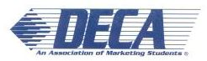
The mission of DECA, Inc. is to enhance the co-curricular education of students with interest in marketing, management and entrepreneurship. DECA helps students to develop skills and competence for marketing careers, to build self-esteem, to experience leadership and to practice community service. For more information go to: www.mddeca.org and www.deca.org

FFA makes a positive difference in the lives of students by developing their potential for premier leadership, personal growth, and career success through agricultural education. For more information go to: www.mdffa.org and www.ffa.org

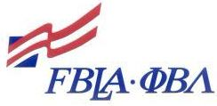
FBLA-PBL is the premier student business association.
The mission of FBLA-PBL is to bring business and education together in a positive working relationship through innovative leadership and career development programs. For more information go to: www.mdfbla.org and www.fbla-pbl.org
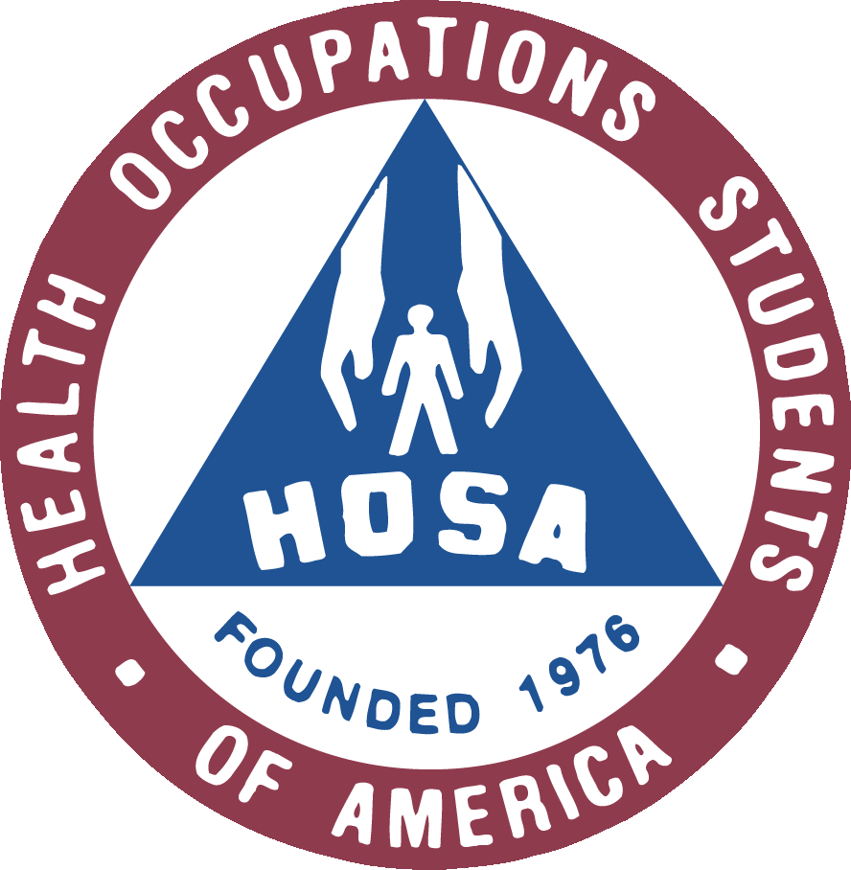
The mission of HOSA is to enhance the delivery of compassionate, quality health care by providing opportunities for knowledge, skill and leadership development of health science technology education students, therefore, helping to meet the needs of the health care community. For more information go to: www.hosa.org
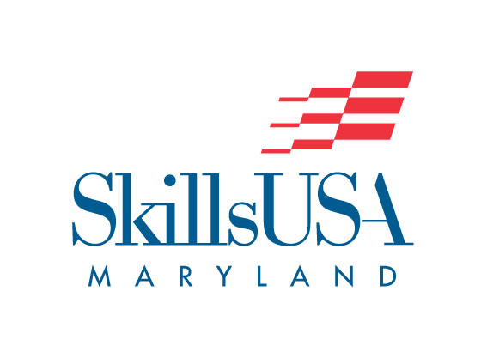
SkillsUSA is a partnership of students, teachers and industry working together to ensure America has a skilled workforce. SkillsUSA helps each student excel. For more information, go to: www.mdskillsusa.org and www.skillsusa.org
IV. Requirements for Maryland CTSO Associations

The successful operation of a CTSO includes a three-way partnership between the Maryland CTSO Association, the Division of Career Technology and Adult Learning, and the National CTSO Association. Each partner contributes to the success of CTE students as they advance their understanding of career opportunities and increase their academic and technical preparation for careers. The unique contribution of each partner is detailed below.

- The Maryland CTSO Associations provide leadership and directly support student leadership and skill development related to a student’s CTE program of study;

- The Division of Career Technology and Adult Learning (DCTAL) provides leadership and support to the CTSO Associations through direct support for professional development and coordination with local school system CTE programs; and

- The National CTSO Association provides guidelines and resources for organizations for competitive events and student leadership development.

To ensure that all state approved programs and resources are aligned to the desired outcomes, a recognized and approved Maryland CTSO Association agrees to:

- File Articles of Incorporation with the Maryland Department of Assessments and Taxation (and the Secretary of State if required by the Maryland Solicitations Act) as a non-profit organization and comply with state regulations regarding operations and financial reporting for Maryland non-profit organizations.

- Establish a CTSO Association Board of Directors (CTSO Board) to be responsible for developing the vision and general operating policies and procedures of the organization as well as ensuring the state charter is in accordance with the national bylaws and state requirements. The CTSO Board also provides fiscal oversight and management for dues, fundraising, and scholarships.

The CTSO Board will include members from Maryland business and industry as well as postsecondary partners representing the career areas corresponding to student CTE programs of study. The Board, directly, or through a committee structure, agrees to take an active role in planning and conducting the organization’s events throughout the year. It is recommended that the Board include seven (7) to 15 members, with at least 50 percent of members representing business, industry, and postsecondary partners. The State CTSO Director shall serve as an ex-officio member with no voting rights. The Board shall develop procedures for electing and appointing members as well as procedures for the rotation and removal of board members. For continuity, it is strongly recommended that these procedures contain a staggered term system.

Each CTSO Board of Directors agrees to have an Executive Team, which includes at a minimum, a chairperson, vice-chairperson, secretary, and treasurer responsible for managing all finances and furnishing an annual audit if required by the Maryland Solicitations Act.

- Provide to the State CTSO Director a copy of the organizational charter or articles of incorporation as a Maryland non-profit organization, a current list of CTSO Board members, and the Board Executive Team contact information.

- Register and hold a charter in good standing with the corresponding National CTSO and meet the standards and reporting requirements of that organization.

All Maryland CTSO Associations will maintain membership in the corresponding national organization to be recognized by DCTAL. The Maryland CTSO Association is responsible for the collection of membership dues and will file annual financial and membership reports as required by the national association, with a copy submitted to DCTAL.

- Coordinate activities with the national organization and local school system with the State CTSO Director, either directly by the CTSO Board or through a committee structure. The CTSO Board further agrees to provide guidance to State Officers, CTSO Teachers/Advisors and business partners in participation in national events and fundraising activities.

The State CTSO Director, working with the Board, will confirm membership status of participants as a requirement for competition at the state and national level. The State CTSO Director will also work with the Board to communicate to the local school systems an annual events calendar including regional, state and national events.

- Ensure alignment of CTSO activities with Maryland approved CTE programs of study and local school system requirements for student participation in a CTE program and CTSO activities.

In partnership with DCTAL, all Maryland CTSO Associations will ensure alignment to CTE programs of study so they offer co-curricular support for CTE student achievement. The CTSO Association provides guidelines and support for chapters to prepare students for competition at the national level (in areas related to the student’s program of study). Student participation in events sponsored by the Maryland CTSO Association, are coordinated through the local school system in accordance with district guidelines. To ensure alignment, each local CTSO chapter must have an advisor who is a faculty member/teacher in an approved CTE program of study.

The CTSO Board coordinates chapter membership through the LSS, including the participation of non-public school students in CTE programs of study, as per the policies of the Local School System.

As a student organization, the election of Student Officers and Chapter Leadership are essential components of a CTSO. As students prepare for State and National-level competition, preparation at the Chapter and Regional level are key to student success. To ensure students are given opportunities for leadership and competition, in alignment with the National CTSO guidelines, at least five (5) CTSO chapters, representing at least three (3) Local School Systems is recommended for State-level competition.

The State CTSO Director, working with the Board and LSS CTE Director, will promote membership in CTSOs related to a student’s CTE program of study. The State CTSO Director will also work with LSS in providing technical assistance and professional development for CTSO Teachers/Advisors.

- Designate an advisor to serve as the State Officer Advisor to monitor the work of State Officers, including the annual plan of work and chapter management support.

The CTSO Board provides leadership to the elected student officers through a State Officer Advisor. The state officers are responsible for providing leadership to local chapters and responding to requirements of the State and National Associations as requested. Guidelines for CTSO Teachers/Advisors and student participation in school-related activities are determined by the LSS.

Contact information for the State Officer Advisor and current State Officers for each CTSO will be provided to the State CTSO Director on an annual basis.

V. Major Functions and Activities of Maryland CTSO Associations

In partnership with DCTAL and the National CTSO, the approved Maryland CTSO Association provides oversight to local CTSO chapters and sponsors state-wide CTSO events. This section provides guidelines for the monitoring local chapters and an overview of state-wide events sponsored by DCTAL and the State CTSO Association.

CTSO Chapter Requirements:

The State CTSO Association establishes policies and procedures for the operation of local chapters. In alignment with state and national requirements, these will address the following minimum requirements:

- A local chapter must be in good standing with the state association in order to participate in state events and activities, as well as National events.

- Active members shall pay all prescribed national, state, and local dues (where applicable) and be students who are enrolled in a course which is part of a state approved CTE program of study aligned with the respective CTSO.
- The student officers of the state CTSO shall be current students (or former students for FFA as required by the National Association) with a GPA of at least 2.5 or higher and must have active membership in the state and national organizations.

Competitive Events Requirements:

- Competitive events shall be aligned to the standards in state approved CTE programs of study to support academic and technical preparation.

- A local chapter must have active membership in the state association in order to participate in state events and activities, as well as National events.

- The events offered at the national level are replicated at the state and chapter/regional level, where aligned to Maryland CTE Programs of Study.

- A member shall progress from winning at the chapter/regional level, to the state level, to the national level. Competition at any of these levels shall not be skipped in order for advancement to the next level, as required by the National CTSO.

- Judges for competitive events shall be individuals from the career field for which they are assigned to judge. They shall possess the expertise and experience necessary to fairly evaluate the competition.

On an annual basis, the State CTSO Director will confirm the list of active chapters, teachers/advisors, and student officers for each Maryland CTSO. The State CTSO Director, in collaboration with the CTSO Board, will also provide updates for each chapter concerning the national events and specific events to be held at the state conference.

MSDE/DCTAL Sponsored Events:

Joint CTSO Officer Training –The State CTSO Directors are responsible for coordinating leadership training for the student officer teams representing all state-recognized CTSOs. This annual event is held in late summer or early fall to prepare state officers for their role as student leaders and facilitators of chapter development and planning. During this event, all student officers are provided guidance on the development of a state-wide plan of work, chapter management and strategies to support successful chapters.

While the event is coordinated by DCTAL, each CTSO Association provides guidance and supervision to the student officers through the State Officer Advisor, designated by the CTSO Board. In partnership with the State CTSO Director, the State Officer Advisor also works with these student officers to develop workshop topics for the annual CTSO Fall Conferences.

Joint CTSO Advisor Training –The State CTSO Directors are responsible for providing professional development for all Maryland CTSO Teachers/Advisors. This annual event is held early in the school year to provide an orientation for new advisors, updates for current advisors and opportunities for chapter support. This event includes specific topic sessions as well as sessions for the respective organizations. Registration of CTSO Teachers/Advisors is coordinated by DCTAL and the Local School System CTE Director.

While the event is coordinated by DCTAL, each CTSO Association provides guidance and support to teachers/advisors through sessions conducted by current CTSO members and CTSO Board sessions.

CTSO Association Sponsored Events:

Fall Leadership Conference – At the start of each school year, the CTSO Association sponsors a conference for its current and prospective (new) student members. The conference includes CTSO Officer-facilitated workshops designed to promote leadership development and serves as a recruitment tool for local chapters. Business partners and college representatives also support and participate in the career development opportunities provided through the Fall Conference. As a result of this conference students develop leadership skills, advance their understanding of career opportunities, and learn about CTSO membership opportunities.

While the event is coordinated by the CTSO Association, DCTAL, through the State CTSO Director, provides guidance and support to the State Officer Advisor and the CTSO Board in working with teacher-advisors and business/postsecondary partners to deliver the program.

Spring State Conference – Near the end of each school year, the CTSO Association sponsors a conference for its current, dues-paying student members. The conference provides additional opportunities for career development, leadership skill development and competitive events related to the student’s CTE program of study. Students must compete at the local and/or regional level to qualify for state competitive events. The annual state conference also allows the students to conduct the business of their respective organizations, such as election of officers and designation of student delegates to the national conference.

While the event is coordinated by the CTSO Association, the State CTSO Director provides guidance and support to the State Officer Advisor and the CTSO Board in working with teacher-advisors and business/postsecondary partners to deliver the program. Based on state competitive events, students who qualify for national competition are certified by the State CTSO Director. A complete list of students eligible for national competition is forwarded to the national CTSO by the State CTSO Director.

State Delegation to the National Conference – Each National CTSO sponsors an annual conference of competitive events, career development events and career exhibitions. The Maryland delegation to the national conference includes student competitors, workshop attendees, state officers and delegates as well as teacher-advisors and chaperones as required by the local school district for students participating in off-campus activities.
The national conference is sponsored by the national CTSO with support from state associations and each State CTSO Director. The State CTSO Director serves as a liaison between the national association, state association and the local school systems to facilitate the registration of the Maryland delegation.

The chart below shows a listing of Maryland and national CTSO Association events throughout the year. Individual organizations may hold additional events throughout the year. Please visit their respective websites for more information.

CTSO Organization | Fall Leadership  Conference | Spring State Conference | National Conference
FFA | September | April | October
DECA | October | March | April/May
FBLA | October | March/April | June/July
HOSA | October | March/April | June
SkillsUSA | November | April | June

VI. CTSO Partner Responsibilities

The State CTSO Director shall be an employee of the Maryland State Department of Education (MSDE) or a representative of an MSDE contractor. Working in partnership with the CTSO Board, the CTSO State Director provides technical and administrative support for CTSO activities. The chart below outlines the responsibilities of each partner – DCTAL, the CTSO Board, and the Local Chapter for each major event.

MSDE/DCTAL  (State CTSO Director) | Board of Directors | State Officer Advisor | Local Chapter:  (Student Officers and Teacher-Advisors)
Joint CTSO State Officer Training
As the sponsor for this event, DCTAL through the State CTSO Director will coordinate all aspects of the conference.  Specific functions include:  - Contracting for facilities, equipment needs, food and beverage and related costs;  - Communicating event requirements to all chapters and managing the registration process;  - Coordinating the agenda and confirming all presenters and workshop needs; and  - Providing on-site coordination of the event. | Although this event is sponsored by MSDE, the Board plays a significant role in planning and coordinating the participation of the State Officers and guiding their training as leaders in the organization. Specifically, through the State Officer Advisor, the Board:  - Develops and participates in portions of the program specific to the organization as requested;  - May provide direct guidance or conduct a meeting with State Officers in preparation for the annual plan of work for the organization; and  - Coordinates chaperone(s) for the state officers. | The Board’s designee to:  - Chaperone State Officers;  - Assists Officer Team with developing the Program of Work; and - -May provide organization specific information and training to the Officers. | The CTSO Teacher/Advisor coordinates the attendance of a State Officer according to the duties of an elected state officer as outlined at the time of election.  State Officers are required to attend and participate in the development of the annual Program of Work.
Joint CTSO Advisor Training
As the sponsor for this event, DCTAL through the State CTSO Director will coordinate all aspects of the conference in partnership with the Board.  Specific functions include:  - Contracting for facilities, equipment needs, food and beverage and related costs;  - Communicating event requirements to all chapters and managing the registration process;  - Coordinating the agenda and confirming all presenters and workshop needs; and  - Providing on-site coordination of the event. | Although this event is sponsored by MSDE, the Board plays a significant role in planning and coordinating the event. The Board influences the training and information shared with teacher-advisors throughout the state. Specifically, the Board:  - Develops and participates in portions of the program specific to the organization as requested; and  - May provide direct guidance or conduct a meeting with Teachers/Advisors to support the annual plan of work for the organization. | The Officer Advisor has no responsibility in this activity. | The attendance of CTSO Teachers/Advisors is coordinated by MSDE through the LSS Director of CTE. Each LSS designates attendance of teachers and may provide additional support to the teacher and/or school.
Fall Leadership Conference
The State CTSO Director assists in the planning and coordination of the event and serves as a liaison to the LSS.  Specifically, the State CTSO Director:  - Attends and bring greetings and welcome as requested;  - Coordinates with the Board regarding the planning of the event;  - Distributes registration materials and coordinates attendance by LSS chapters; and  - Assists the Board with planning the logistics of the event, securing the facilities, and handling registration.  - Serves as on-site logistical coordinator and conference point contact. | As the sponsor of this event, the CTSO Board:  - Contracts for the logistics of the event, including the facility, equipment and food and beverage as required;  - Coordinates registration and the collection of fees;  - Designates an on-site competition event coordinator and hotel point of contact.  - Coordinates a chaperone(s) for State Officers, as required by the respective Local School System | - Provides oversight and guidance to the State Officers on workshop development and delivery; and  - Prepares Officers for General Sessions | The student officers for each CTSO take a leadership role in the design and implementation of the Fall Conference, specifically they:  - Develop the conference agenda and workshops for the event; and  - In accordance with the CTSO Plan of Work, the CTSO Student Officers publicize and recruit chapter participation.
Local/Regional Qualifying Events
The State CTSO Director assists in the planning and coordination of the event and serves as a liaison to the LSS.  Specifically, the State CTSO Director:  - Attends and bring greetings and welcome as requested;  - Provide exams and production work as needed and required by the national CTSO; and  - Arranges for online exams and verifies results, as required by the National CTSO. | The CTSO Board ensures compliance with the National guidelines for students to qualify for competition. These requirements are specified by each National CTSO Association.  The Board coordinates the following:  - Assists with conference planning as requested by local or regional advisor(s); and  - Works with local or regional advisors as requested to speak, judge, or present awards. | The Officer Advisor has no responsibilities in this activity. He/she may assist as requested by the local event coordinator. | The Teachers/Advisors for each CTSO are responsible for preparing students for CTSO events and competition. Specifically they:  - Ensure students are aware of the national and state guidelines for participation in CTSO events;  - Coordinate with other local advisors to plan and facilitate the local/regional events to determine students’ eligibility for participation in state events; and  - Submit results of all events/competitions to the State CTSO Director as requested.
Spring State Conference
The State CTSO Director assists in the planning and coordination of the event and serves as a liaison to the LSS.  Specifically, the State CTSO Director:  - Assists in identifying industry and postsecondary partners to serve as event judges as requested;  - Coordinates an individual (other than the Director) to bring greetings on behalf of MSDE and DCTAL;  - Assists the Board of Directors with planning the logistics of the event, securing the facilities, and handling registration;  -Provides event updates and registration materials to local chapters and the CTE Directors for each LSS; and  -Serves as on-site logistical coordinator and conference point contact. | As the sponsor of this event, the CTSO Board:  - Contracts for the logistics of the event, including the facility, equipment and food and beverage as required;  - May develop a committee structure for the planning and implementation of the event;  - Coordinates registration and the collection of fees;  - Provides oversight and guidance to the State Officers in planning and conducting leadership and chapter events;  - Coordinates a chaperone(s) for State Officers, as required by the respective Local School System  - Coordinates with the State CTSO Director to identify judges for competitive events; and  -Designates an on-site competition event coordinator and hotel point of contact. | The Board’s designee to:  - Provides oversight and guidance to the State Officers in planning and conducting leadership and chapter events; and  -Prepare Officers for all sessions. | The Teacher-Advisors for each CTSO are responsible for preparing students for CTSO events. Specifically they:  - Ensure students are aware of the national and state guidelines for participation in CTSO events; and  - Coordinate chapter registration, participation and chaperones as required by the school district.  The student officers for each CTSO take a leadership role in chapter events including:  -Presiding over delegate meetings, award ceremonies, and conference sessions.
CTSO National Conference
The State CTSO Director assists in the coordination of the state delegation and serves as a liaison to the LSS.  Specifically, the State CTSO Director:  - Attends the National Conference and specific events/meetings as required by the National CTSO;  - Certifies National competitors and distributes registration materials and information regarding conference logistics (including hotel block information coordinated through the National CTSO); and  - Serves as key contact for Teachers/Advisors and students during the event. | The CTSO Board ensures compliance with the National guidelines for students to qualify for competition. These requirements are specified by each National CTSO Association.  The Board coordinates the following:  - Coordinates the logistics for the Maryland delegation (including the hotel rooms, travel, and registration);  - Coordinates with the State CTSO Director to confirm participation of the Maryland delegation – competitors, officers and voting delegates; and  - May sponsor specific events or students in attending the national conference. | The State Officer Advisor has no responsibility in this activity. | The Teacher-Advisors for each CTSO are responsible for preparing students for CTSO events Specifically they:  - Coordinate the registration and logistics for chapter members; and  - Identifies chaperones as needed and required by the LSS.  The student officers for each CTSO may attend and participate in Officer functions as coordinated by the State Officer Advisor.

Appendix A:
Maryland CTSO State Directors

All written correspondence should be addressed as follows:

Student Organization
Directors Name
Maryland State Department of Education
Division of Career Technology and Adult Learning
200 West Baltimore St
Baltimore MD 21201
Fax: 410-333-2099

DECA and FBLA
Mr. Lou Kaminski
Phone: 410-767-0190
Email: lkaminsk@msde.state.md.us

FFA
Mr. Matthew Koerner
Phone: 410-767-0189
Email: mkoerner@msde.state.md.us

HOSA and SkillsUSA
Mr. Chuck Wallace
Phone: 410-767-8872
Email: cwallace@msde.state.md.us

