Advance CTE
Research Request
Secondary CTE Programs: Teacher Training (Prepared for Maine)

Request: Meg Harvey from Maine has asked us to pass along this research request:
- Does your state offer secondary CTE programs that offer teacher training? If so,
  - What standards do you use?
  - Which curriculum do you use?
  - Is it a one or two year program?
  - What CIP code do you use for classification?

Marci Johnson, State CTE Director from Illinois, added an additional question to this request:
- As a follow up to this email, for those that have the CIP for teacher training. Are there any specific qualifications for a teacher who teaches this CIP?

The following states submitted responses: Arizona, Connecticut, Delaware, Maryland, Missouri, Nevada, New Mexico, North Carolina, North Dakota, Oklahoma, Rhode Island, US Virgin Islands, Utah, and West Virginia. To visit one state’s response directly, click on that state’s name in this section. Arizona and Maryland both sent responses to the additional request from Illinois.

The offer of secondary CTE programs that include teacher training varies state by state. Additionally, states that do offer such programs have differing standards. The responses sent by each state are below.

Arizona
In Arizona, we have a program called Education Professions. We use 13.1200.00 as the CIP. It is a two-year program. I have attached our technical standards. We use the Praxis Para-Pro as the industry certification. [Included attached documents].

[In response to the question from Illinois]: I have attached Arizona’s certification requirements for Education and Training. We have several options to obtain certification. [Included attached documents].
Contact:
Cathie Raymond
Deputy Associate State Superintendent/ State Director for Career and Technical Education
Arizona Department of Education
Cathie.Raymond@azed.gov

Connecticut
Connecticut does not have a program.

Contact:
Harold Mackin
Director, Career and Technical Education
Connecticut State Department of Education
Academic Office
Harold.Mackin@ct.gov

Delaware
DE’s work related to our teacher academy programs is attached. We run three/four credit and six credit versions of both instructional models (comprehensive and technical schools). Rita is copied should you have additional questions (rita.hovermale@doe.k12.de.us). [Included attached documents]

Contact:
Luke Rhine
State CTE Director
Delaware CTE and STEM Office
Delaware Department of Education
luke.rhine@doe.k12.de.us

Maryland
Lynne Gilli, State CTE Director for Maryland, sent Teacher Academy certification requirements in response to the question from Illinois. [Included attached documents].

Contact:
Lynne Gilli
Assistant State Superintendent and Program Manager for Instruction
Maryland State Department of Education
lynne.gilli@maryland.gov

Missouri
Attached is information pertaining to Missouri’s Career Pathways for the Teaching Profession program offered through Family Consumer Sciences. [Included attached documents]

Contact:
Dennis Harden
Coordinator, Career & Technical Education
Department of Elementary and Secondary Education
Dennis.Harden@dese.mo.gov

Nevada
Yes; Nevada has established Teaching & Training CTE program standards, See Nevada’s Course Catalog, pp. 35; 37-38 for the course descriptions/CIP codes.

Contact:
Kristine Nelson
Director
Office of Career Readiness, Adult Learning and Education Options
Nevada Department of Education
knelson@doe.nv.gov

New Mexico
Please see responses below. Additionally, you might be interested to know that we are running a pilot in partnership with UNM’s Project ECHO (www.echo.unm.edu ) to further enhance interest and participation in secondary, postsecondary and alternative pathways to teaching.

- Does your state offer secondary CTE programs that offer teacher training? New Mexico does offer secondary CTE programs for teacher training
- If so,
  - What standards do you use? The secondary CTE teacher training programs are aligned to the Common Career Technical Core standards (NASDCTEc) for the Teacher/Training Career Pathway (ED-TT).
  - Which curriculum do you use? We are using Educators Rising, the Career Technical Student Organization (CTSO), as a platform for the teacher training CTE POS; we are implementing the CERRA Teacher Cadet curriculum. This occurred after our state was chosen to pilot the curriculum in 2017. The final choice of this curriculum was made on the basis of cost, and the comprehensive nature and quality of the curriculum.
  - Is it a one or two year program? The programs of study (POS) offered can be taken across a two year+ timespan.
  - What CIP code do you use for classification? We do not organize our secondary programs according to the Classification of Instructional Programs (CIP) coding.

Contact:
Elaine Perea
Director
New Mexico Public Education Department
College and Career Readiness Bureau
Elaine.Perea@state.nm.us

North Carolina
The NC CTE New Teacher Induction Program was designed to target the specific needs of new lateral entry CTE teachers, who may be subject matter experts (SME) in their respective fields, but have little experience and knowledge as to how to effectively deliver curriculum content to students in today’s classroom while seamlessly navigating a myriad of administrative expectations. To that end, consultants from multiple CTE program areas collaborated to isolate the most common threats to retaining qualified teachers and reducing turnover. Focusing on three distinct areas, the current content of this course has proven to be a tremendous resource and lifeline for new teachers:

- Curriculum and Instruction
- Resources, Work-based Learning and Support
- The CTSO Experience

The attached blueprint includes the standards to which the content is aligned. This hybrid course (online and face-to-face) requires approximately 40 hours to complete but may be completed throughout the first three years of a teaching career. Should you require additional information, please advise. [Included attached documents]

Contact:
Adkins "Trey" Michael
Director, Career and Technical Education
North Carolina Department of Public Instruction
trey.michael@dpi.nc.gov

North Dakota
North Dakota does not offer secondary CTE programs that offer teacher training.

Contact:
Wayde Sick
State Director
Career and Technical Education
wasick@nd.gov

Oklahoma
CIP code 13.1501
SOC code 25-9041

One-year program-525 hours

Curriculum:
*Melissa Michie, Coordinator, Oklahoma Teacher Connection mmichie@osrhe.edu
- Educators Rising
- Lead Oklahoma
- Teach Oklahoma

Teaching, Goodheart-Wilcox
First Days of School, Harry Wong
The Classroom Management Book, Harry Wong

[Included attached documents]

Contact:
Marcie Mack
State Director
Oklahoma Department of Career and Technology Education
marcie.mack@careertech.ok.gov

Rhode Island
Here are Rhode Island’s standards for CTE programs in education:
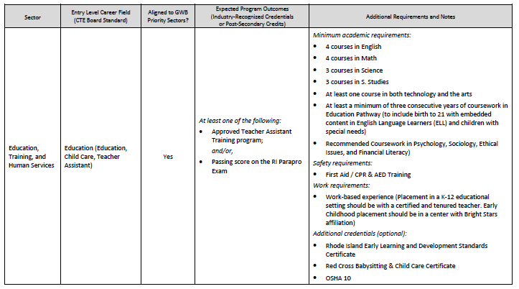
This comes from our CTE Board Standards document, available at ride.ri.gov/cte or here.

Contact:
Spencer Sherman
College and Career Strategy Fellow, Office of College and Career Readiness
Rhode Island Department of Elementary & Secondary Education
spencer.sherman@ride.ri.gov

US Virgin Islands
The Virgin Islands does not.

Contact:
Mrs. Nancy E. Callwood
Director, State Office Career & Technical Education and Adult Education
US Virgin Islands Department of Education
St. Thomas, US Virgin Islands
ncallwood@doe.vi

Utah
- Does your state offer secondary CTE programs that offer teacher training? Yes – just starting.
- If so,
  - What standards do you use? We have developed our own standards by pulling from other states that we could find.
  - Which curriculum do you use? Each LEA determines their own curricular resources – we only develop state standards. We do not define curriculum or resources to teach the standards.
  - Is it a one or two year program? Our Education (K-12 Teaching as a Profession) pathway has three required courses plus some electives. The courses are generally semester-long. The full pathway still requires 3.0 credits in order to be considered a “completer” but that is made up of both required and elective courses.
  - What CIP code do you use for classification? 13.1206

Contact:
Thalea Longhurst
State Director, Career & Technical Education
Utah State Board of Education
thalea.longhurst@schools.utah.gov

West Virginia
- Does your state offer secondary CTE programs that offer teacher training? YES
- If so,
  - What standards do you use? We use the NOCTI standards while incorporating Higher Education Teacher Prep standards.
  - Which curriculum do you use? We have developed the curriculum through a collaborative partnership with Marshall University and completers of our Careers in Education program feeds directly into Marshall University’s Teacher Preparation Four Year program.
  - Is it a one or two year program? It is four core courses, which include specialization courses depending on whether the student is Early Childhood, Elementary, or High School track. Students who are completers earn college credit in the Teacher Prep program.
  - What CIP code do you use for classification? 13.01 and we use Onet classification.

Contact:
Kathy J. D’Antoni
Associate State Superintendent
Career Technical Education
kdantoni@k12.wv.us

