|  |  |
| --- | --- |
| **Student Demographics**  **(233)** | **Percentage** |
| Male | 49% |
| Female | 51% |
| Low Income | 25% |
| Learners With Disabilities | 14% |

Preparing first-generation learners for a future in plant science

Mishicot High School is located in a village in Manitowoc County with 1,400 residents. The school serves approximately 25 percent low-income learners. In addition, about 80 percent of the school’s graduates are first-generation college learners. To help learners fully understand their postsecondary education options, all participants are required to tour a minimum of three technical colleges.

To ensure that support is available, all learners have an Individualized Learning Plan and during academic counseling with their adviser and families choose courses that align with their post-high school plans. In this meeting, learners discuss opportunities such as work-based learning, dual enrollment and the college admissions process.

Sustaining partnerships with educational institutions, such as Northeastern Wisconsin Technical College, Fox Valley Technical College and Lakeshore Technical College, is essential to creating seamless transitions for learners into postsecondary education. Since 2012, learners have had the option to take three college-level courses and earn nine credits specific to plant science. They also have had the option to enroll in general education dual credit courses and take Advanced Placement exams in biology and environmental science to earn additional credit. As a result of this access and encouragement, 89 percent of 2017 graduates completed 12 or more college credits while in high school.

In addition to providing college credits, education partners host horticulture conferences, competitions and campus tours and offer guest speakers for classes.

Overview

The plant science program of study at Mishicot High School in Mishicot, Wisconsin, was developed with support from local businesses and the community. The program has evolved from a single plant science class into a full program of study that offers the ability to earn college credits through articulation agreements and Advanced Placement. Learners can also earn industry certifications in plant science and principles of floral design.

The plant science program of study benefits from partnerships with more than 30 local businesses, such as Wilfert Farms, Woodland Dunes, Lakeside Foods, Brilliant Blooms and Natural Beauty Plant Growers. All learners are required to participate in work-based learning, which ensures that learners understand new trends in the field and opens doors to future employment opportunities.

Mishicot High School

Plant Science

*Agriculture, Food & Natural Resources Career Cluster*

A bright future in youth apprenticeships   
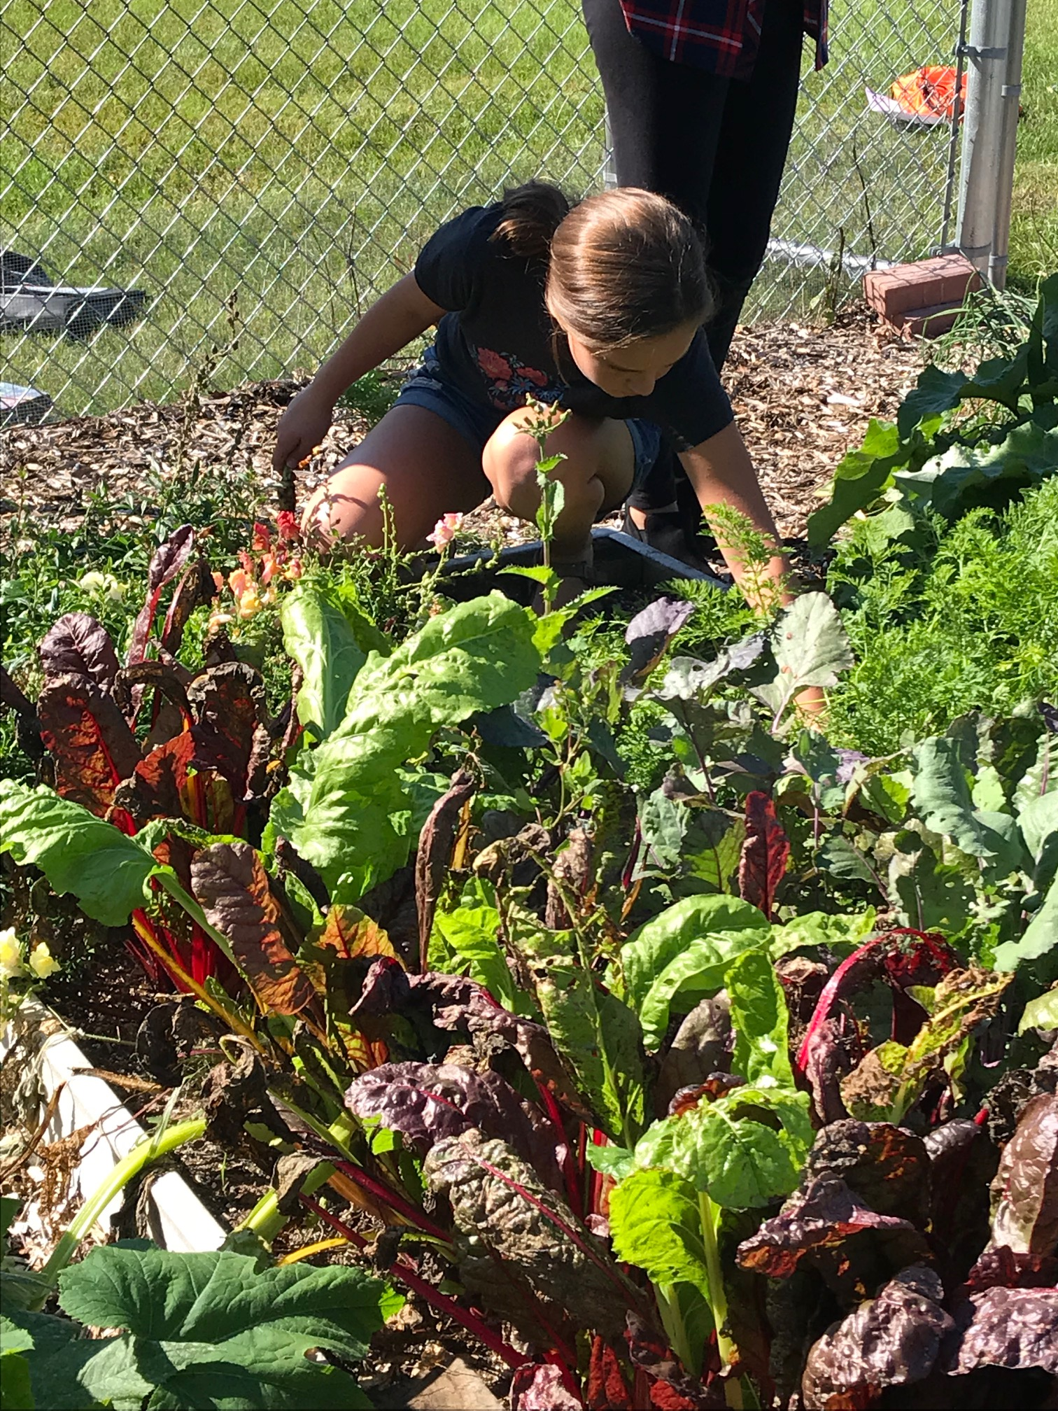  
In 2017-18, Manitowoc County invested $109,800 in the Manitowoc County Youth Apprenticeship Program. Learners choose to apply to participate in the rigorous one- to two-year program starting their junior or senior year. The apprenticeship program combines academic and technical classroom instruction with paid on-the-job training. Learners work at least 450 hours a year and receive a quarterly employer evaluation to ensure that the competencies are being met. Currently, learners in the plant science program participate in apprenticeships focused on agronomy and horticulture with local businesses.

In the future, the plant science program hopes to expand learner and employer participation in this work-based learning opportunity.

Hands-on Learning with FFA  
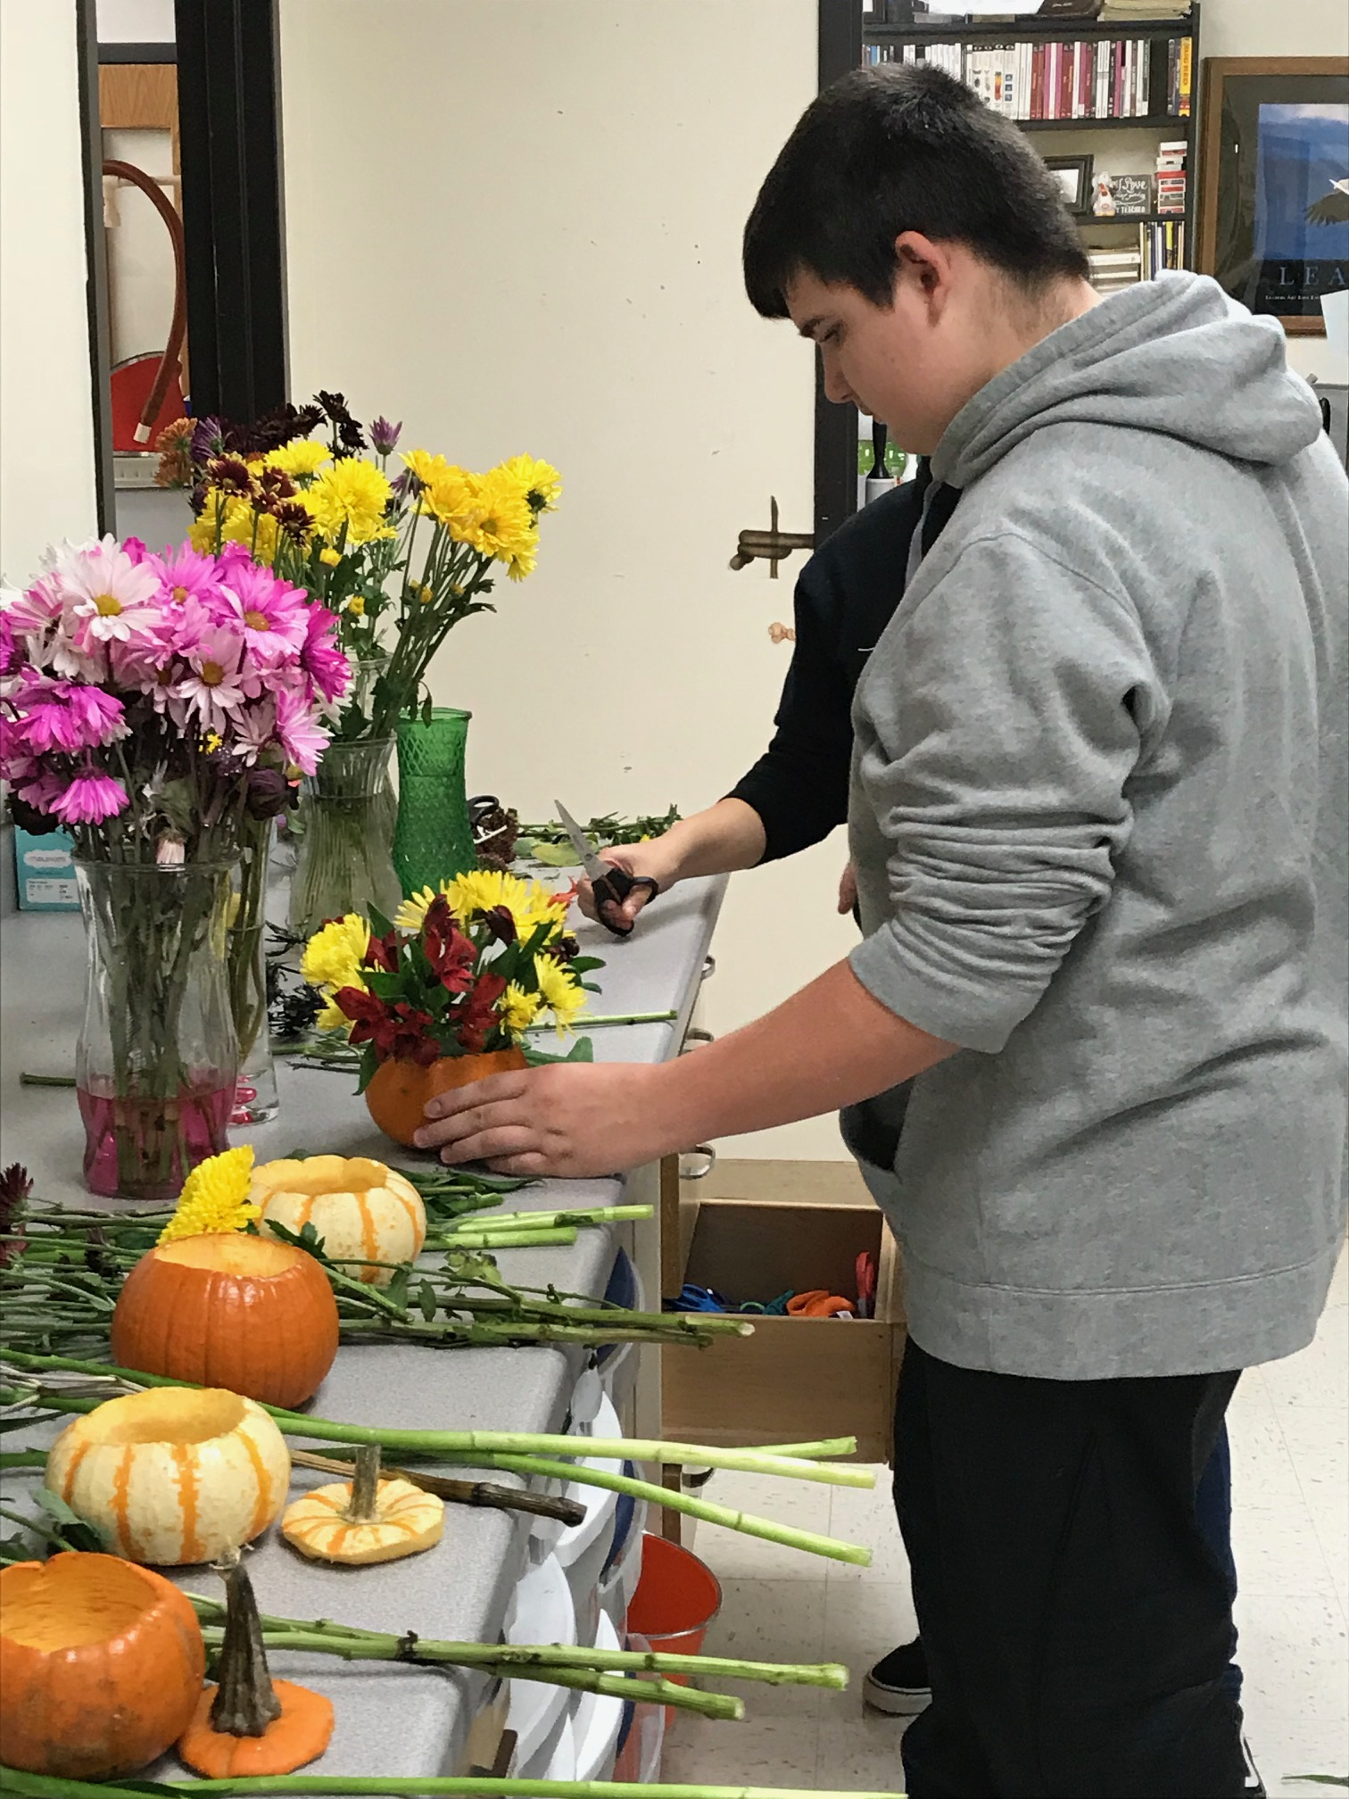  
There are a total of 116 learners participating in the National FFA. FFA is a Career Technical Student Organization (CTSO) that provides opportunities for learners to engage in hands-on learning and gain experiences through leadership positions.

The local chapter launched a floral business in which learners assemble and sell boutonnieres and corsages for high school dances and create floral arrangements for high school performances. They also give back to the community through food drives, including donating to the community fruit they grow in their own orchard.

Through FFA, learners also play a vital role in promoting the agriculture program, giving middle school presentations and even creating an agriculture club for elementary school learners.

The program of study benefits from more than 200 alumni who provide financial and educational support to learners.

**Success by the Numbers**

Mishicot High School



100%  
Participated in   
Work-Based Learning

100%  
Graduated  
High School



“Our students are becoming life-long learners and are passionate about plant science. They are learning how to identify plants and will even send us a photo of a succulent they saw while attending a conference. Seeing their excitement for learning and overall success is what we’re most proud of.” — Jamie Propson, Agriscience Teacher, Mishicot High School Quote

*Data based on 2017-18 school year*

11%  
Earned an   
Industry-Recognized   
Credential

88%  
Enrolled in   
Postsecondary  
Education

100%  
Earned Postsecondary   
Credit