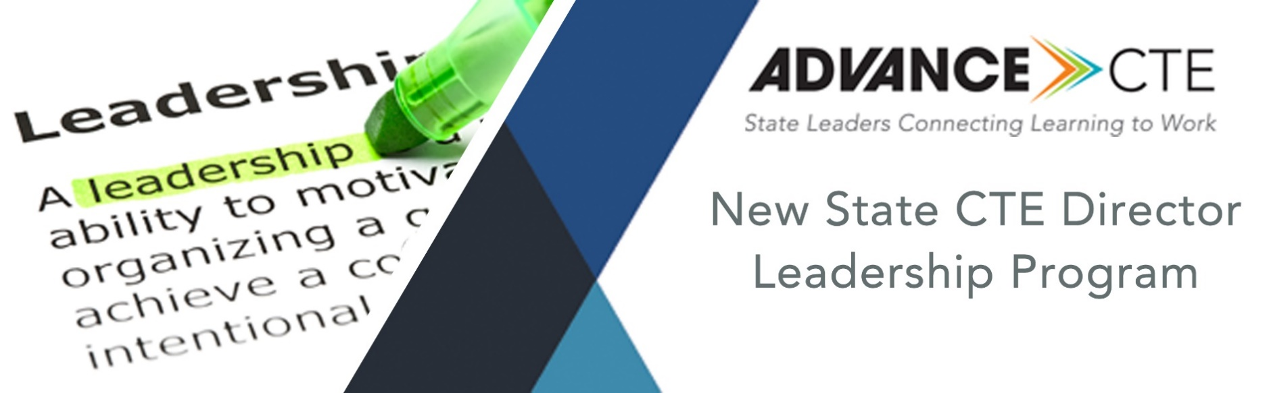

Module 1:
Being an Effective State CTE Leader
Fall 2018

A Note from the Executive Director
Congratulations on being selected as the State CTE Director!

You are taking on this leadership role during an especially exciting time. We are seeing unprecedented interest and support for Career Technical Education (CTE). Being the State Director is an amazing opportunity and responsibility. We know you have a lot on your plate. There are legislative sessions, budgets, annual reports and maybe even an impending federal monitoring visit. In short, there are fires to put out and politics to navigate.

Through all of this, it may feel difficult to find the breathing space to step back, take stock and see the opportunity through the chaos, but I want to encourage you to do just that. Consider using this time as a new State Director to be inquisitive, and – through that inquisitiveness – challenge assumptions, ask questions, and create a path forward that ensures each learner in your state has access to high-quality CTE programs of study.

That’s why we created the New State CTE Director Leadership Program. It is our hope that this program, your mentor and our staff will create a safety net that will give you the confidence to explore and analyze your state CTE system and make the bold choices necessary to create a truly equitable system.

In this module, you’ll hear directly from people who have walked in your shoes – current and former State Directors. They will provide you with some advice they’ve gleaned from their years as a state CTE leader. We also will provide you with a strengths-based assessment to help you better understand your leadership qualities and how you can use those in your new role.

In my 25 years with Advance CTE, I’ve seen the CTE field and our State Directors change dramatically. Today, I see my role as being both an advocate for the field but also an advocate for the learners we serve. When you see excellence in action in every corner of the nation and in every type of community, you know it’s possible. We hope to inspire and support you as your advocate, partner and critical friend as you chart a path forward for your state that is progressive and fiercely dedicated to equity, access and quality.

Kimberly Green
Executive Director
Advance CTE / The Center to Advance CTE

Contents
How to Use the Modules 4
Module Objectives & Pre-Module Survey 5
Module Objectives 5
SECTION 1: About Advance CTE 6
About Our Work 6
Federal Policy 6
State Policy 6
Promotion 7
Professional Development 7
SECTION 2: Understanding Your Leadership Strengths 8
Take the test! 8
Landscape of State Directors and State CTE Offices 10
Vision for CTE 11
Partnerships and Initiatives 12
Strengthening the State-to-Local Relationship 13
Empowering Your Staff 14
Now Breathe… 14
Final Reflections & Next Steps 16

How to Use the Modules
The New State Director Leadership Program is designed to fit the natural learning curve of new State CTE Directors as they explore their state CTE system as well as the policies and decisions that undergird it. To that end, Advance CTE has developed a 12-month curriculum with two in-person meetings, two webinars and intermittent optional phone calls to provide comprehensive supports to these new leaders. The program, with its curriculum, touchpoints and mentorship, is designed to allow new State Directors to access the support they need, when they need it.

This module is part of the 12-month curriculum that is designed to help you be inquisitive about your state’s current “state of play,” evaluate the responses and information you gather, see what gaps exist and determine if, how and when you may want to take action. By answering the guiding questions and adding data where appropriate, you will be able to better visualize both where you are currently and where you want to take your state system.

The modules are laid out to help you organize your thoughts and guide effective discussions with your mentor and Advance CTE staff who can help you consider and benchmark your findings, as well as provide resources, support and targeted technical assistance as you work your way through the modules.

Disclaimer: The modules do not constitute or replace legal advice. We encourage you to check with any relevant state and federal guidance and regulatory requirements to ensure compliance. Further, the examples listed within are not endorsements nor should be considered a comprehensive list.

Module Objectives & Pre-Module Survey
Module Objectives
This module is designed to help you identify your personal leadership skills and apply this to your role as State Director. Through this module, you will:
- Understand your unique strengths as a leader;
- Understand the similarities and differences in state CTE governance systems; and
- Learn from experienced State Directors.

Pre-module Survey
To begin this module, please take this brief self-assessment, and choose the “Being an Effective State CTE Leader” option: https://www.surveymonkey.com/r/2018-19-new-sd-test

SECTION 1: About Advance CTE
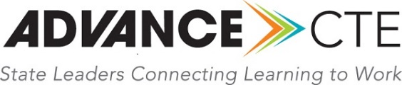
Advance CTE: State Leaders Connecting Learning to Work is the longest-standing national non-profit that represents State Directors and state leaders responsible for secondary, postsecondary and adult Career Technical Education (CTE) across all 50 states and U.S. territories. Advance CTE was formerly known as the National Association of State Directors of Career Technical Education Consortium (NASDCTEc).

Established in 1920, our Mission is to support visionary state leadership, cultivate best practices and speak with a collective voice to advance high-quality CTE policies, programs and pathways that ensure career success for each learner. Our Vision is to transform and expand CTE so that each learner – of any background, age and zip code – is prepared for career and college success through state leadership, advocacy and partnerships.

About Our Work
We build our work around policy, promotion and professional development. This work is carried out by our national staff. You can reach out to them at any time.

Federal Policy
Advance CTE is your national advocate for CTE. Our federal policy team engages with Congress, the executive branch and the many national education and industry partners to build relationships and foster partnerships to advance our legislative and budget priorities for CTE and career readiness.

Our federal policy team works across the federal education and workforce laws to show how CTE is the bridge builder that connects all of them. Chief among this work is our advocacy and implementation support for the Strengthening Career and Technical Education of the 21st Century Act (Perkins V). You can also check out our resources for the Higher Education Act, Every Student Succeeds Act and the Workforce Innovation and Opportunity Act.

State Policy
Our state policy work is grounded in answering the question, “What is the state’s role?” We understand that there is no one-size-fits-all approach to state policy and implementation, which is why we work hard to highlight an array of promising practices and examples of quality in everything we do.

Throughout the year, we track state legislatures and review the latest research through our blog. We also curate a one-of-a-kind CTE Learning that Works Resource Center, where you can find briefs and reports created by the state policy team, as well as resources from states and other organizations. As a team, we also lead Advance CTE’s role in the New Skills for Youth Initiative, a multi-year partnership with the Council of Chief State School Officers and Education Strategy Group, generously funded by JPMorgan Chase, to strengthen career-focused education. Our state policy work also extends into postsecondary, leading a project with support from the Joyce Foundation to help states and institutions support high-quality CTE programs.

Promotion
No policy, law or plan will ultimately be effective without a clear, persuasive communications plan. While we know that CTE works, we need to get the message out about the importance of CTE for every learner. To do this, we need to each every audience from policymakers to parents. It’s imperative that you are not only armed with the best policy analysis and research but also understand how to communicate effectively about these issues.

We do this by honoring what high-quality CTE looks like through our Excellence in Action awards. We are also here to help you communicate and market CTE through our national branding campaign and a growing suite of tools, resources and technical assistance.

Professional Development
The cornerstone of Advance CTE’s professional development are our bi-annual meetings, where you can join your peers from across the country to learn the latest trends, participate in workshops that will challenge your thinking and give you fresh energy and ideas to bring back to your state.

We also offer virtual professional development throughout the year as well as in-state technical assistance and specialty programs such as the New State CTE Director Leadership Program.

SECTION 2: Understanding Your Leadership Strengths
This program is designed to give you a blend of content knowledge and leadership development. We firmly believe that everyone has the capacity to be an effective leader and like CTE, there is no singular definition for what that looks like.

Instead, we prefer to think about how people and teams use their talents to work with information, make things happen, influence others and build relationships. At Advance CTE, we use Clifton Strengthsfinder® from Gallup to help each person better understand how they can use their unique strengths to contribute and lead.

For the New State CTE Director Leadership Program, we have purchased a license that allows us to offer each participant the opportunity to take this test for themselves. If you have already taken this test, there is no need to take it again. Simply forward your top 5 strengths to Andrea at azimmermann@careertech.org.

Take the test!
Please follow the instructions below to take the CliftonStrengths assessment and discover your strengths.

- Visit https://www.gallupstrengthscenter.com/register/en-us/index
- Copy and paste the access code WB88KN78YJ23YG54 into the available field, and then click Continue.
- Follow the onscreen instructions to create a Gallup Strengths Center account.
- Once registered, you will be able to take the CliftonStrengths assessment. Please give yourself 45 minutes of uninterrupted time to complete it.

*Note: Please do not share this code with anyone else. This code was purchased only for you and we have just enough for the entire cohort.

After you complete the assessment, Advance CTE will be able to view your results to coach you in strengths development. If you encounter issues with your access code, please contact Andrea. For all other issues, please view the Gallup Strengths Center Help page.

Please take the test by October 1. We will use these results in our first monthly call to discuss concepts of leadership.
SECTION 3: What is State CTE Leadership?
You are now part of a community of state CTE leaders. Since CTE sits at the intersections of education, the workforce and economic development, you have partners in agencies across state government to support your CTE system. You may have champions in business leaders and the state legislature. Yet, we also know that being the State Director can, simultaneously feel isolating.

That’s why it’s important at Advance CTE to make sure to connect State Directors across the country to help this community of state leaders ask questions, compare systems and practices, and support one another. To develop this module, we reached out to current and former State Directors to share their collective wisdom with the community’s newest leaders.

We’d like to thank the following individuals for offering their advice to support this module:
Sarah Heath, State Director from Colorado and 2018-19 Advance CTE Vice President; Bernadette Howard, State Director from Hawaii and 2018-19 Advance CTE President; Rich Katt, retired State Director from Nebraska; Marcie Mack, State Director from Oklahoma and 2018-19 Advance CTE Secretary/Treasurer; Mike Raponi, former State Director from Nevada.

Based on these interviews, here’s a snapshot of what’s most important for state CTE leadership:

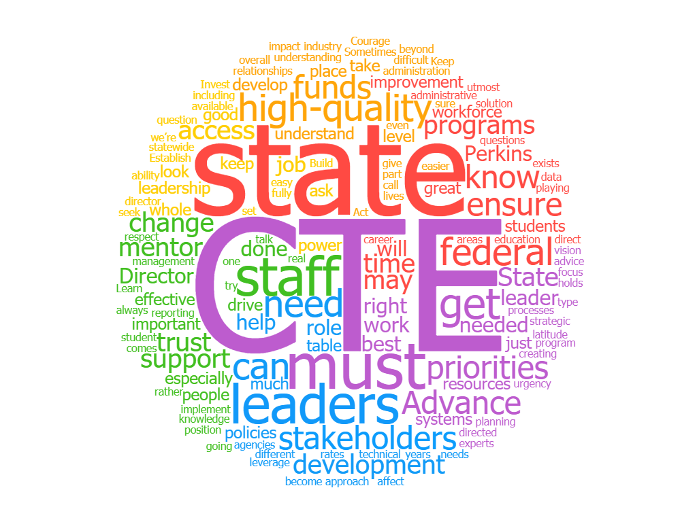

Landscape of State Directors and State CTE Offices
A common question we hear from new State Directors is about how alike or different their state CTE offices are compared to others. We believe that each state’s context should ultimately guide CTE governance decisions, including where the state CTE office resides. What’s more important is how your systems are aligned to provide the most effective, efficient experience for learners. Because CTE connects to and is delivered through multiple systems – including K-12 and postsecondary education, workforce development and economic development – its success is interwoven with that of other program and systems.

State Directors are often well positioned to foster this collaboration through their role in overseeing the implementation and administration of Perkins. With its explicit focus on systems alignment and program improvement, this law has been critical to ensuring CTE programs meet the ever-changing needs of learners and employers. The State Director often works with multiple state agencies, which provides the opportunity to promote alignment across systems and agencies to drive toward a statewide vision for CTE.

The state CTE office is determined by which state agency serves as the eligible agency to receive and administer the federal Perkins funds. In 2017, all but 14 states use the state education agency as the Perkins Eligible Agency. In those 14 states, the state CTE office resides in:

- Postsecondary systems (CO, HI, IA, KS, LA, MN, MT, WI and Guam)
- Standalone CTE agencies (AR, ID, ND, and OK)
- Workforce Development Board (WA)

Advance CTE President Bernadette Howard leads the state system in Hawaii, which may have some unique challenges compared to a landlocked state. Yet, she cuts to the heart of the matter:
“We all have the same issues – big states, small states. Fundamentally, they are all the same fights. You don’t have to learn everything the hard way. Help avoid some of the pitfalls we had [by leaning on fellow State Directors for advice].”
In most states, the State Director job is typically a career position, with the exception of five states, in which this role is a political appointee. In the chart that follows, you can see the array of responsibilities that often fall under the purview of State Directors. The prominence and portfolio of State CTE Directors have grown significantly over the past 20 years. This expansion could naturally lead a state CTE office toward a state of compliance and administration. Focusing on the sheer number of duties could mean you spend much of your day putting out fires.

Former Nebraska State Director Rich Katt understands the breadth of a State Director’s responsibilities and urges leaders to keep perspective and not get hung up on just Perkins administration duties:
“It’s very easy to become caught up in the administration of the Perkins Act and to let that solely define the role of the State CTE Director. No question, the administration of the Perkins Act is important and requires due diligence. The management of the Perkins Grant is a systems issue – the State Director must put the appropriate systems in place so accountability, data, monitoring, etc., are happening with staff assigned to cover those systems and report to the State Director. This allows the State Director to focus on leadership for CTE.”
Most importantly, your range of responsibilities gives you opportunities to foster collaboration across different state agencies and initiatives. This collaboration can take many forms, but regardless of the approach, strong coordination between CTE and other statewide efforts can be the critical driver of progress across systems and toward a statewide vision for CTE.

Vision for CTE
Over the course of this program, we will repeatedly revisit the topic of your state’s vision for CTE. You may not have one on Day 1 and perhaps it’s unclear what your predecessor’s vision was. That’s entirely normal. You have the opportunity now to establish a clear North Star for your state CTE system.

In 2016, Advance CTE partnered with 11 national organizations to advance Putting Learner Success First: A Shared Vision for the Future of CTE, setting a bold vision for where our education system needs to go to ensure all learners find career success. The vision is articulated through five principles:
- All CTE programs are held to the highest standards of excellence.
- All learners are empowered to choose a meaningful education and career.
- All learning is personalized and flexible.
- All learning is facilitated by knowledgeable experts.
- All systems work together to put learner success first.

As you begin the work of establishing or refining your state’s vision for CTE, our veteran State Directors have some advice for you:

Former Nebraska State Director Rich Katt underscores the importance of having a clear vision and how it provides crucial direction for your staff, your Perkins grant recipients and business and industry stakeholders.
“You need the courage and freedom to look beyond what has been done before. Freedom comes from both within the agency and from a group of supportive stakeholders. Courage – that’s the internal fortitude that pushes you to do what you know is right. It’s not about making enemies or creating animosity among stakeholders, it’s creating a compelling vision that pulls them to the future. … Market your successes to build relationships and support. Sometimes change is easy but real improvement through change is much more difficult.”

Partnerships and Initiatives
When Howard assumed the State Director position in Hawaii seven years ago, her predecessor told her she might get bored because there wasn’t that much work to do. Yet, since that time, CTE both in Hawaii and nationally has risen to a level of unprecedented prominence. Today, CTE is a key component of gubernatorial and legislative packages. It has caught the attention of the business community and even some education stakeholders who previously were uninterested in CTE.

This shift means that you as the State Director may be getting invited to be at tables of all kinds. If you’re not careful, it might also mean that discussions about CTE might also be happening without you.

For Howard, it’s important for the State Director to be both a convener and a diplomat as you work to build trust with partners inside and out of government.
“Be sure you’re at the table to be the expert on CTE. When [people not familiar with CTE] try to implement things from the CTE world, they may not get it right because they may not have a good perception of what it is today and the power it has to transform lives. Make sure at be all these of these meetings – there needs to be a CTE leader at the table. … You really have to be a diplomat and a good communicator. If we’re going to get people to understand that CTE is part of the solution, we need to be diplomatic and tactful. We need to be the convener, not just wait to be asked.”

Key to this work is learning who your counterparts are in other state agencies and actively working to build trust with them.

Howard continues:
“We are a key player and a big part of the solution [in our states], but people don’t always see that up front. You have to keep building the trust. Recognizing when to push and when to back off a little until people are ready to come on board is an important skill to develop.”
Colorado’s State Director and Advance CTE Vice President Sarah Heath assumed her role just a few years ago after serving as a local CTE director. One of her earliest and most important lessons was about partnerships:
CTE is tied to so many state initiatives such as work-based learning, apprenticeships and other workforce components like industry credentials. I feel it is important as the state leader of CTE to be at all of the different “tables” of other state agencies and associations to ensure CTE is considered in planning.
In Oklahoma, CTE is its own standalone agency. State Director and Advance CTE Secretary/Treasurer Marcie Mack is always collaborating with other state agencies and industry partners. This work is not easy but critical:
“Never lose sight of the difference CTE makes in individuals lives, even though others may want to discount the impact. … Make certain that the state leaders, stakeholders, and others know the impact CTE has in the state and to continually be pushing CTE to the next level.”

Strengthening the State-to-Local Relationship
At its core, you as the State Director have a responsibility for administering the Perkins grant and monitoring how your local recipients use the money they receive for CTE programs. However, if this is the extent of your work with local recipients, you are missing a key potential partner in achieving your state’s vision for CTE.

In fact, Heath in Colorado has a simple message – get out of the office and visit local programs.
“There is a balance that comes with being an overall state leader. You represent the whole state and all of the different sizes of locals. It is critical to get out and visit everyone especially the type of local [program] you do not have personal experience leading or a type of place you have not taught at. The same holds true if you were a CTE teacher – get to know the other CTE areas and spend time with every CTSO.”
As State Director, you will make decisions every day, and for those decisions that will have a direct impact on your local programs, it’s important to engage the people who are doing the work on the front lines.

From Heath:
“Always include the “field” in your decision making processes. People are more likely to comply and understand if they are part of the whole process and you treat them with respect.”
In your first year, you will likely hear a similar refrain from your local programs. “We can’t do that,” but that’s unlikely to be the case. In some instances, you might need to get creative, but you can usually a tool to achieve what you’ve set out to accomplish. This is also why we at Advance CTE routinely talk how you can use about Perkins – and other federal laws – to achieve your vision for CTE. By taking this approach, you’ve flipped the paradigm on its head. No longer will federal regulations solely dictate your actions. Instead, you’ll be able to use the tools and levers available to you within these federal laws to shift your state from a compliance mindset to one focused on continuous improvement. Ultimately, your focus should be on improving equity, quality and access to all CTE programs.
From Nevada’s Raponi:
Understand the power and latitude available to leverage and direct state and federal funds to support essential state needs and priorities. With respect to federal funds, direct them wisely and don’t accept preconceived notions where the “tail wags the dog.” That is, there is more latitude for directing federal funds to support state priorities than might at first meet the eye.

Empowering Your Staff
To achieve your goals and move the CTE system forward, you’ll also need to invest a significant amount of time in bringing your staff along with your plans. In fact, your staff may initially be the loudest in the chorus saying what you can and can’t do. This is why it is equally as important that you build your own knowledge and fully understand what levers and opportunities are at your disposal.

Learning to delegate and lean on your staff will help to gain their trust. Honor that they have been doing this work before you arrive. They can be your accomplices in helping achieve your state’s vision for CTE. They serve as the first line of contact for the field. If you want to make a major shift in how you approach the work, you need to make sure your staff are bought in and feel as if they are also a part of the shift.

Colorado’s Heath agrees:
“Engage your team in processes as you never know when you will need them to step up on your behalf and it is much easier if you have empowered them the whole time.”
Nebraska’s Katt served as State Director for more than three decades. In that time, he always invested in his staff’s development:
“Build and trust your staff. Make sure they have the knowledge and tools to do their job. Invest in professional development for yourself and your staff. Don’t be afraid to use statewide leadership funds to help develop your staff. Don’t micro manage – your staff will make you look good if you give them what they need to do the job and get out of their way. Keep an open door and check in, but don’t constantly monitor.”

Now Breathe…
At the start of our cohort’s monthly check-in calls, we’ll begin with two pictures – one is a child superhero looking confident and ready to take on the world; the other is attempting to drink from a large hose.

Inevitably, you may feel like one of those pictures – or perhaps some combination of a superhero who is drenched from drinking all day from a fire hose.

But your veteran State Directors are here to assure you – it does get better. Katt, who recently retired after 37 years at the Nebraska Department of Education, recommended leaning on your mentor and the entire State Director community.
“Keep the job in perspective – don’t let it overwhelm you from Day 1. It will all get done, take some time for yourself so you can be at your best at work. Remember to breathe! Invest in your personal development and that of your staff.
“It’s very easy to become caught up in the administration of the Perkins Act and to let that solely define the role of the State CTE Director. No question, the administration of the Perkins Act is important and requires due diligence. The management of the Perkins Grant is a systems issue – the State Director must put the appropriate systems in place so accountability, data, monitoring, etc., are happening with staff assigned to cover those systems and report to the State Director. This allows the State Director to focus on leadership for CTE.”
Raponi agrees:
“This is much easier said than done, but don’t let the constant, never-ending barrage of ‘emergencies’ and administrative tasks detract from strategic thinking and planning. The barrage will never go away, so it must be managed. A philosophy of continuous improvement should permeate the state CTE office—the work is never done.”
Howard reinforces the unique support from other State Directors and Advance CTE.
“Just ask for help and keep asking for help. The rest of us are here to help you. When I need something from another State Director, I ask whether its bouncing an idea or just letting off steam. And definitely look to Advance CTE. They have great resources and support for you.“

Final Reflections & Next Steps
It is our sincerest hope that this module has given you a sense of the exciting opportunities ahead of you. Perhaps you’ve already started to think about the changes you’d like to make. Some may be small steps or changes you can make today while others may require you to build a cohesive plan for more dramatic shifts in the future. Just know that we at Advance CTE stand ready to help as critical friends, content experts, and providers of professional development and technical assistance.

