|  |  |
| --- | --- |
| **Student Demographics**  **(60)** | **Percentage** |
| Male | 48% |
| Female | 52% |
| Minority | 25% |
| Learners With Disabilities | 12% |

career exploration with partners

Nashua High School North is located nearly 50 miles from Boston, MA, one of the largest biotechnology hubs in the country. In the Boston region there are more than 1,000 biotechnology companies, employing nearly 100,000 people. This demand creates opportunities for the Biotechnology program to develop valuable partnerships with business and industry.

For the past two years, the Massachusetts Biotechnology Education Foundation (MassBioEd) has served as an active partner. MassBioEd provides professional development opportunities and facilitates career exploration days for learners at eight life science organizations in Massachusetts. The career exploration days help learners understand the full breadth of opportunities in the field. Throughout the day, learners participate in facility tours and in-lab demonstrations.

Over the past six years, sophomores and juniors in the Biotechnology 1 course have had the opportunity to visit another partner, the Massachusetts Institute of Technology Edgerton Center. During the visit, learners participate in a hands-on workshop about DNA and protein synthesis using LEGO® bricks. Learners can manipulate the models to perform DNA replication, mRNA transcription, DNA damage, DNA mutation, DNA repair and more. The workshop helps learners to visualize and apply what they learned in the classroom.

Additional partners include Advanced Regenerative Manufacturing Institute, MilliporeSigma and Corning Life Sciences, which also provide field trips to their facilities.

Further, the Biotechnology program also has an active advisory committee, consisting of education partners, including representatives from Pelham High School, Riviera University and Greater Bay Community College.

Overview

The Biotechnology program of study at Nashua High School North in Nashua, NH, was launched in 2003 to provide learners with rigorous and integrated academic and technical coursework in the biotechnology field. Throughout the two-year program, learners master the advanced laboratory techniques most in demand for medical and scientific careers, such as analyzing cell structures, DNA extraction, molecular cloning, chromatography, protein purification and data collection. Learners demonstrate an understanding of the skills they have acquired by completing a capstone their first year and a research project their second year. Through dual credit courses with Great Bay Community College, Biotechnology learners can earn up to eight college credits, creating a seamless transition to postsecondary education.

Nashua High School North  
Biotechnology

*Science, Technology, Engineering & Mathematics   
Career Cluster*

Meeting the Needs of all Learners

Learners at Nashua High School North are provided with additional time during the day to seek support and/or enrichment during a 35-minute class called an E-block. This dedicated time is especially important for learners who need extra help to receive it without sacrificing after-school responsibilities such as a job or caring for family members. For example, special education students and English language learners can meet with their case managers.

In addition to providing support, teachers create opportunities focused on aiding the transition from high school to college and career. These opportunities include career seminars, college application process sessions, college essay writing sessions, SAT prep sessions and guest lectures.

Further, a Career Technical Education paraprofessional was recently hired to assist students who require additional help.

putting skills into practice

Biotechnology 1 learners complete a capstone in which they are given a test tube containing one of eight well-characterized microbes and have to determine which antibiotic will cure their fictitious “patient” infected with the unknown microbe. This scenario affords learners the opportunity to realize the value of the work done by a hospital microbiologist and how the skills they have learned must be integrated to solve a problem.

Biotechnology 2 learners are required to design and execute an independent research project. Learners choose a research topic, perform experiments, solve problems, analyze the results, and present their findings through a formal research paper. Learners have the option to present their research at the New Hampshire Science and Engineering Exposition, an annual science fair for high school students.

This experience helps them conduct a research project from beginning to completion, mirroring what happens in the workplace. In 2016, three students won first place in the Earth and Space Science, Biochemistry and Biology categories. In 2017, one student won second place in Biology. In 2018, one student won first place in the Chemistry category, and two students won second place in Biology and Biochemistry.

**Success by the Numbers**

Nashua High School North

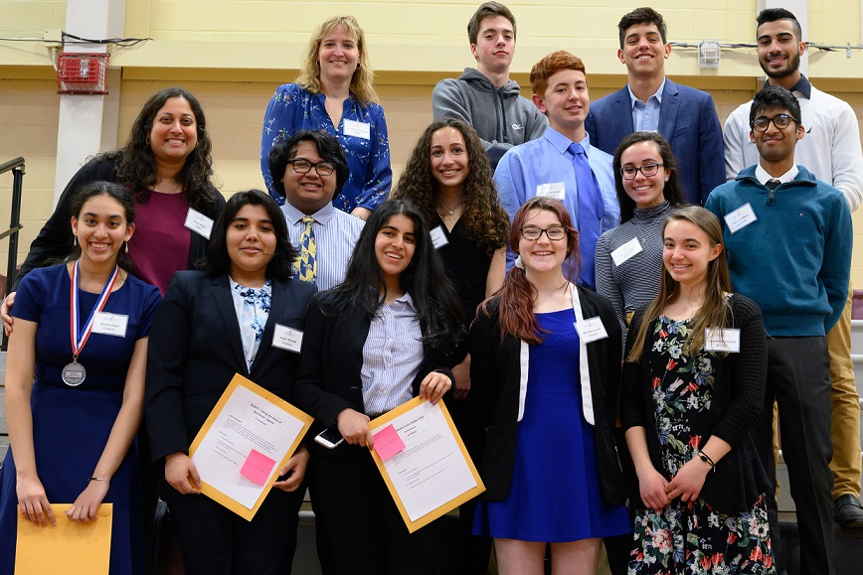

“I’m proud of the teachers. They care deeply about their students. Education research tells us that students learn better when they have a positive relationship with the teacher. I think that the student success outcomes for this program demonstrate that our teachers care deeply about their students.” — Amanda Bastoni, Director of the Nashua Technology Center for Nashua High School North

100%  
Graduated  
High School

100%  
Participated in   
Work-Based Learning

*Data based on 2017-18 school year*

89%  
Earned an Industry-Recognized   
Credential

100%  
Enrolled in   
Postsecondary  
Education

71%  
Earned Postsecondary   
Credit