|  |  |
| --- | --- |
| **Student Demographics**  **(54)** | **Percentage** |
| Male | 40% |
| Female | 60% |
| Minority | 28% |
| Learners With Disabilities | 20% |

Meeting industry demand through Partnerships and hands-on learning

The Criminal Justice program was developed in response to labor market needs and learner interest. According to the New York State Department of Labor’s long-term occupational employment projections for the region, careers as detectives and criminal investigators, police and sheriff’s patrol officers, and security guards are all projected to grow significantly between 2014 and 2024.

The Rensselaer Center is housed within Capital District, NY, home to a number of police and sheriff’s departments, family courts and correctional facilities, which creates many opportunities for valuable partnerships. Partners, such as the Troy City Policy Department, contribute to the program in a number of ways, including annually providing feedback on the curriculum and offering internships.

Work-based learning is a core element of the program of study. All seniors are required to complete a minimum of 25 hours at an employer-sponsored internship. Learners, with assistance from the work-based learning coordinator, contact an industry employer of their choosing and set up an interview. Work-based learning opportunities range from working with an officer in the dispatch center to doing a ride-along in an emergency vehicle, depending on the learner’s post-high school career plans.

Learners are also able to earn industry certifications in the areas of private security, corrections and public safety dispatching, as well as several Federal Emergency Management Agency certifications, often gaining immediate employment in the field after graduation while attending a postsecondary institution.

Overview

The Questar III BOCES Criminal Justice program of study at the Rensselaer Educational Center in Troy, NY, was launched in 2003 to provide learners with rigorous coursework, hands-on experience, mentorship, and clear pathways to further education and the workforce.

The Criminal Justice program prepares learners, drawn from 10 surrounding school districts, for postsecondary studies and careers in law enforcement and the criminal justice system. Throughout the two-year program of study, learners can also earn 12 college credits through articulation agreements with Bryant and Stratton College, Columbia Greene Community College and Schenectady County Community College.

Questar III BOCES Rensselaer Educational Center

Criminal Justice I & II

*Law, Public Safety, Corrections & Security Career Cluster*

Meeting the needs of EACH learner   
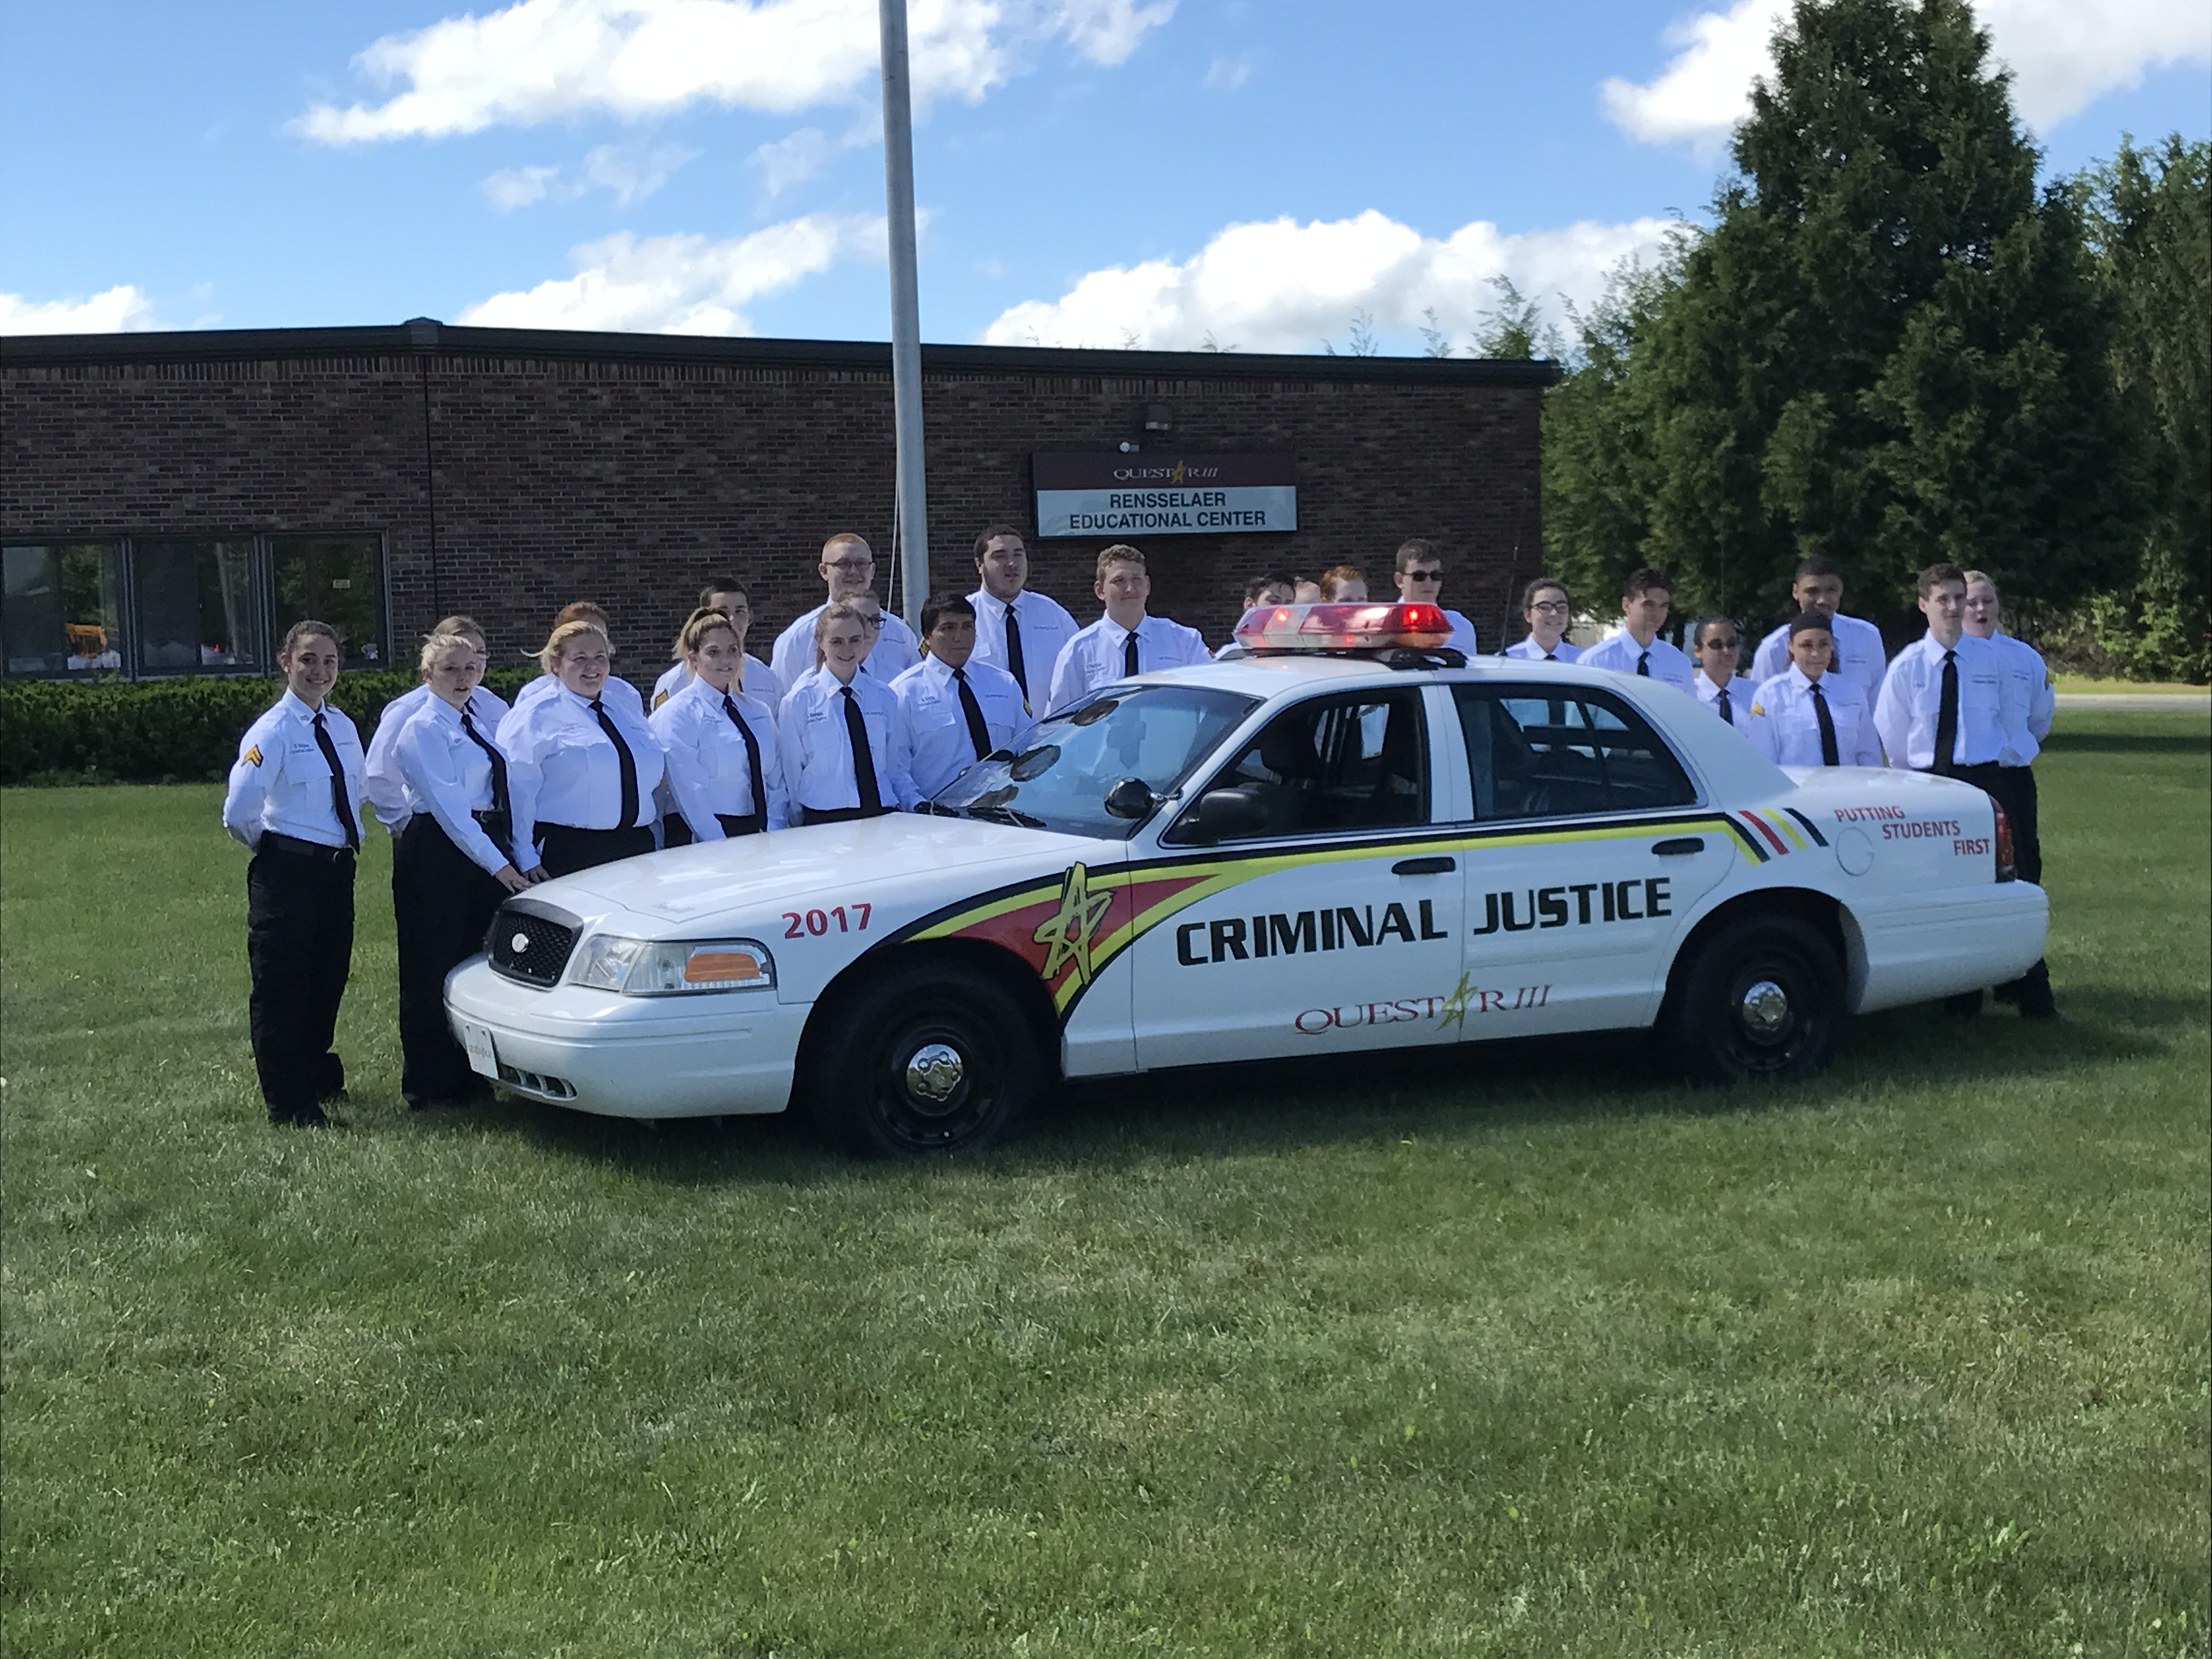

Serving learners from so many surrounding districts requires the program to provide a range of supports to ensure that all learners are set up for success.

For example, 20 percent of the program’s learners have disabilities. A special education consultant works directly with learners and instructors on students’ individualized education program goals and provides strategies and supports to help meet the learning needs of each student through the context of the program of study.

Student success outcomes show learners’ needs are being met. For example, learners achieved a near 100 percent pass rate over the past eight years on the Criminal Justice National Occupational Competency Testing Institute exam, a required test for all seniors in the program.

Further, in 2018, an equity team was formed and is making strides to provide more inclusive working environments for all learners. The team is made up of instructors and staff who are learning about mental health awareness and ways to improve equity and counter potential bias.

**Success by the Numbers**

Questar III BOCES Rensselaer Educational Center



“We want to make sure that students come away with a strong knowledge base and industry credentials that prepare them to be successful in the criminal justice field. — Dr. Danielle Bouton-Wales, Director of CTE, Questar III BOCES

100%  
Participated in   
Work-Based Learning

100%  
Graduated  
High School

meeting a community need   
In 2016, after learning that surrounding counties had a shortage in public safety telecommunicators or dispatchers — those responsible for receiving and responding to telephone or other electronic requests for emergency assistance — the program ensured that an instructor was trained and certified to prepare learners for this career.

Learners working toward earning the Public Safety Telecommunicator I Certification will work with the same equipment they would use on the job, such as a two-station computer system or 911 simulator. The Capital District is home to three 911 centers and at least five smaller police departments that employ their own dispatchers, and learners can participate in local work-based learning internships.

*Data based on 2017-18 school year*

100%  
Earned an Industry-Recognized   
Credential

86%  
Enrolled in   
Postsecondary  
Education

100%  
Earned Postsecondary   
Credit