Career Readiness Data Quality and Use Policy Benchmark Tool
State Implementation Guide
The Career Readiness Data Quality and Use Policy Benchmark Tool is accessible at dataquality.careertech.org.
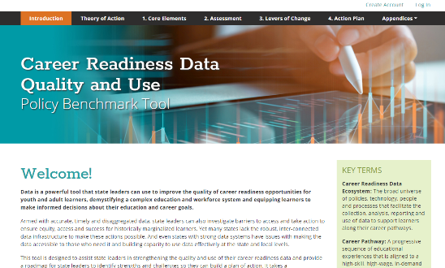

This implementation guide is designed to accompany the Career Readiness Data Quality and Use Policy Benchmark Tool to provide further guidance for using the tool. The primary audience for this implementation guide is state-level Career Technical Education (CTE) leaders, including State CTE Directors and their staff. It is meant to help them convene a statewide data quality team, identify strengths and challenges with their current data ecosystem, and develop a plan of action to improve the quality and use of career readiness data. However, the guide can be easily adapted by local leaders to understand and improve the use of CTE data in their postsecondary institutions and school districts.
This resource includes tools, guides and templates to help you make the most of the Career Readiness Data Quality and Use Policy Benchmark Tool, but it is not meant to be prescriptive. The steps outlined below describe one way that the tool can be implemented, but it is not the only way. You should adapt the guidance below based on your own state context and needs.
The resource follows five steps to effectively complete and implement a data quality action plan using the policy benchmark tool:

Step 1: Plan the Work
Step 2: Select a Team
Step 3: Host a Kickoff Meeting
Step 4: Complete the Needs Assessment
Step 5: Create an Action Plan
Step 6: Execute

Step 1: Plan the Work
Depending on whom you decide to include in the state leadership team, their schedules, and other urgent priorities such as reporting deadlines, the process of completing the needs assessment and action planning tool can take two to three months. Planning the timeline before you begin the work can help you stay on track and ensure that all participants are aware of the commitment.
Table 1 includes a sample timeline that can be adapted to suit your state’s specific circumstances. This plan includes two touchpoints with the full data quality project team: a kickoff meeting and a goal-setting meeting. You might choose to add additional check-in meetings throughout.

Table 1: Sample Three-Month Timeline for Completing the Policy Benchmark Tool
 | Week
 | 1 | 2 | 3 | 4 | 5 | 6 | 7 | 8 | 9 | 10 | 11 | 12
Identify state leadership team
Hold kickoff meeting
Complete needs assessment
Hold goal-setting meeting
Develop action plan
Get consensus on action plan
Execute action plan

Considerations
- Consider connecting the timeline for this project to a specific forcing event such as a legislative session, a rewrite of your state’s Strengthening Career and Technical Education for the 21st Century Act (Perkins V) plan or other activity. Look ahead at your calendar and work backward from opportunities that will give you the most leverage for implementing a comprehensive action plan.
- Determine whether other planned work or events might limit the availability of your project team and create a timeline that works with their schedules.
- Identify whether there are other planned meetings during which you could convene your project team (e.g., quarterly strategy meetings).

Step 2: Select a Team
The success of your plan will depend entirely on the strength and diversity of your team. Too often, the silos that are built between agencies and organizations are reflected in the way data is collected and used. A high-quality data ecosystem breaks down these silos to ensure that learner-level data can be connected and accessed across education levels. To that end, this tool will be most useful if it is completed by a cross-functional team representing different roles, expertise and learner levels.
This tool will be most useful if it is completed by a cross-functional team representing different roles, expertise and learner levels.
However, before you start to think about your team, the initial step is to designate a project owner. This person will be responsible for coordinating the work, scheduling meetings and ensuring that everyone has the information they need. You may want to select someone from your own office, hire a third-party consultant (who can bring a neutral perspective), or even designate yourself as the project owner.
To build your team, fill out the table below with the names of individuals who represent different roles and perspectives.
Table 2: Data Quality Project Team
Role | Name(s)
Project owner: Person who will be responsible for coordinating the work, scheduling meetings, and ensuring that everyone has the information they need
State leadership: Individuals with responsibility for policymaking or administration of education, workforce and social service programs, including the secondary and postsecondary State CTE Directors, program administrators and others | 1.  2.  3.
State data administrators: State-level data administrators with oversight and responsibility for education and workforce data, including representatives from the state longitudinal data system, the workforce longitudinal data system, the unemployment wage records data system, and the labor market information system | 1.  2.  3.
Local data administrators: Secondary and postsecondary representatives at the local level including local administrators, institutional researchers and others responsible for collecting and reporting data | 1.  2.  3.
Local practitioners: Individuals who interact with learners, report data and/or use data in some capacity, such as teachers, faculty, school counselors and advisers | 1.  2.  3.

Considerations
- How inclusive is your project team? Are all relevant stakeholders represented? Consider going through the needs assessment before convening your project team to ensure that all questions can be answered by your group.
- Your participants may have questions about the purpose of the project and level of commitment. Consider creating a one-pager that describes at a high level the scope and timeline for the work.
- If your invited participants are unavailable, see if they can send substitutes who understand the challenges and limitations of their office, agency or organization.
- Before you convene the full project team, gathering input from other stakeholders who are part of the career readiness ecosystem, including learners, families, advocacy groups, employers and researchers, may help. Consider surveying these stakeholders or organizing focus groups to get critical input.

Step 3: Host a Kickoff Meeting
Scheduling a kickoff meeting will get all project participants oriented to the work and ensure that they understand their roles and responsibilities. Use the sample objectives and meeting agenda below to design an effective kickoff meeting for your workgroup. You may want to modify this agenda depending on your team, your state context, and your priorities for the meeting.
Data Quality Project Team Kickoff Meeting
Recommended time: 60 minutes
 | Meeting Objectives  - Orient the data quality project team to the policy benchmark tool and project plan.  - Set a shared vision for career readiness data.  - Ensure that participants understand their roles in the project. |  |  | Materials  - Post-it notes  - Printouts of the policy benchmark tool and/or a screen to share the web-based tool  - JamBoard/Miro/other virtual collaboration tool
 | Meeting Agenda
 | Time | Activity | Facilitator Notes
 | 10 min | Welcome and Introductions  - Facilitator will welcome participants and introduce the agenda for the session.  - Participants will introduce themselves. | - Use this time to introduce participants to one another and describe their professional responsibilities and role in supporting career readiness data quality.
 | 10 min | Overview of Project  - Facilitator will describe the purpose of the project.  - Facilitator will describe roles and responsibilities for participants. | - Provide some contextual background information about this project. How is data currently being used in your state? What do you see as some of the biggest challenges you hope to address? What are the forcing events (e.g., Perkins V panning) that are anchoring this project?  - Explain what a high-quality career readiness data ecosystem looks like. Refer to the Career Readiness Data Quality and Use Policy Benchmark Tool.  - Share a broad overview of the timeline and scope of the project.
 | 30 min | Career Readiness Data Quality Vision Setting  - Participants will work together to generate a shared, cross-sector vision for a high-quality career readiness data ecosystem. | - The purpose of this session is to establish a shared vision for career readiness data in your state.  - (5 min): Instructions  - Provide instructions for the activity.  - Present your state’s career readiness vision from your Perkins V plan or another source.  - (5 min): Silent brainswarm  - Hand out post-it notes to all participants.  - Instruct them to reflect silently on the state’s career readiness vision.  - Instruct participants to use post-it notes to describe what the data ecosystem must look like to achieve this vision for career readiness. They can use as many post-it notes as they like. Once they have written down their ideas, they can add their post-it notes to a board or post them on the wall where all group participants can see.  - NOTE: For virtual meetings, consider using a tool such as Miro or JamBoards to conduct a virtual brainswarm activity.  - (15 min): Discussion  - Summarize the ideas shared on the post-it notes from the brainswarm activity. As you review and share post-it notes, group them by major themes.  - As a group, discuss whether there are any themes that are missing on the wall. What other components are necessary to establish a data ecosystem that will enable us to achieve our vision for career readiness?  - As a group, discuss any specific themes or ideas that need additional context.  - (5 min): Next steps  - Explain how these notes will be used to develop a shared vision for a career readiness data ecosystem.
 | 5 min | Process for Completing Needs Assessment  - Participants will understand how to access and complete the needs assessment tool.  - Participants will understand how and when they will need to submit their scores to the project manager. | - Provide a brief overview of the policy benchmark tool and the needs assessment.  - Describe the six core elements of a high-quality career readiness data ecosystem, using the Core Elements section of the policy benchmark tool.  - Explain how participants will be expected to complete the policy benchmark tool. Be sure to specify:  - Whether they are completing the tool online or in the PDF;  - When they are expected to submit their completed assessments;  - To whom they should send completed assessments; and  - What they should do if they do not know how to respond to specific elements in the policy benchmark tool.
 | 5 min | Next Steps  - Facilitator will review the next steps for project. | - Summarize next steps and confirm the time for the next meeting.  - Hand out any final materials that are needed to complete the needs assessment.
Considerations
- Are you hosting the kickoff meeting in person or virtually? If the meeting is virtual, you may need to make some slight adjustments to the pacing and facilitation. Use web-based collaboration tools such as JamBoard or Miro to facilitate group brainswarming activities.
- How large is your project team? If your group is larger than 20 people, you might consider using breakout rooms for some of the discussion activities.
- Do all of your participants have an understanding of CTE and career readiness opportunities in your state? If not, consider adding more context to ensure that everyone is on the same page.

Step 4: Complete the Needs Assessment
Tip: Consider creating a Google form for participants to submit their individual responses. An online form can help you aggregate and calibrate the scores for each element and sub-element.
Between the kickoff meeting and the goal-setting meeting, your participants will complete the needs assessment tool. Needs assessments should be completed individually by each project team participant. They may not have all of the answers to each question, but they should complete the needs assessment to the best of their knowledge. Participants should set aside up to two hours to complete the tool.
Once they complete the needs assessment, participants should send the results to the project lead to compile and share with the full group at the goal-setting meeting. There are two versions of the policy benchmark tool that you can share with participants as they complete the needs assessment (see Table 3).

Table 3: Options for Completing the Needs Assessment
 | Benefits | Instructions | Link
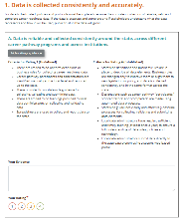  Web-Based Tool | - Has no limitations on character count.  - Enables an auto-generated summary of the participant’s responses to be sent to them. | - The project lead sends participants the link and instructs them to complete the needs assessment to the best of their knowledge.  - Responses are required for all sub-elements. If participants do not know how to respond, they should provide a rating of 1 and write “don’t know” in the comments.  - Once they complete the needs assessment they will be directed to a summary report. They should save the report as a PDF and email the PDF to the project lead. | Click here
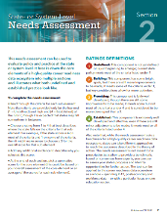  PDF Version | - Allows participants to skip questions they do not know how to answer.  - Can be printed for participants to fill out by hand. | - Participants should complete the needs assessment to the best of their knowledge.  - Once completed, participants should email the PDF to the project lead. | Click here

Considerations
- Structure this activity in a way that will make it easier for you to compile needs assessment ratings. You could ask participants to enter their ratings in a Google form or share their ratings by email in a machine-readable format. Completing assessments by hand might be easier for participants but will be a headache for you later on.
- Encourage participants to submit their scores early so you have time to compile and aggregate them before the goal-setting meeting.

Figure 1: Sample Summary Report of Needs Assessment Ratings
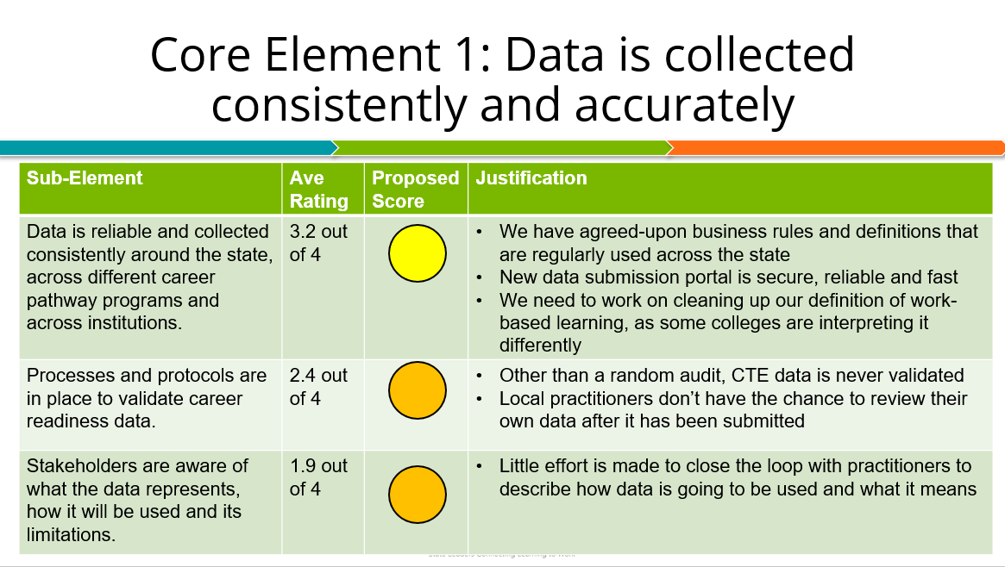

Step 5: Create an Action Plan
Once you have received ratings from your full project team, the next step is to bring everyone together to calibrate scores, develop long-term goals, and identify next steps and roles. This section includes a sample plan for a planning meeting with your full project team. Make sure your project team participants send you their final ratings at least one full week before your planning meeting to give you time to review scores and prepare to share them with the full group.
Prior to your planning meeting, you will need to analyze and summarize the needs assessment results. You can share this summary with participants as a short memo, a presentation deck, an Excel spreadsheet or however you prefer. Make sure that this document includes:
- The average rating for each core element and sub-element across all project team members;
- A proposed color score (rounded up or down to the nearest whole number);
- A summary of evidence provided (if any) for each core element and sub-element; and
- An indication of core elements or sub-elements with significant variance across the full project team.
See Figure 1 for a sample summary report for one of the core elements of the needs assessment.
The goal-setting meeting will require approximately three hours of time with your project team. The proposed agenda on the following pages is split into two parts. The first part is 60 minutes long, and the second part is 120 minutes long. You might choose to host the full session in one day with a lunch break or a coffee break in between. Or you might choose to break it up over multiple days. You can also modify the agenda to extend or condense the timing as needed.

Data Quality Calibration and Goal-Setting Meeting Part I
Recommended time: 60 minutes
 | Meeting Objectives  - Calibrate and reach consensus on final needs assessment scores.  - Identify and agree upon statewide strengths and challenges. |  |  | Materials  - Summary report of needs assessment scores  - Physical or virtual board for sharing notes (flipchart, whiteboard, Google document, etc.)
 | Meeting Agenda — Part I
 | Time | Activity | Facilitator Notes
 | 5 min | Welcome and Overview of Agenda  - Participants will reintroduce themselves, and the facilitator will review the objectives for the day’s meeting. | - Use this time to reintroduce participants and revisit the objectives and agenda for the day’s meeting.
 | 25 min | Calibration of Scores  - Participants will review the synthesized needs assessment results and reach consensus on final scores. | - The purpose for this session of the meeting is to reach consensus and finalize the ratings for each of the core elements and sub-elements in the policy benchmark tool. Each sub-element will need to have a rounded score — a 1 (red), 2 (orange), 3 (yellow) or 4 (green). In the interest of time, focus your conversation on the parts of the needs assessment where there is the most discrepancy across ratings to reach consensus on a final score. For all others, round the score up or down depending on the average.  - (5 min): Overview of scores  - Present a high-level overview of the policy benchmark tool ratings. Share the average score, the proposed rounded score, and a summary of justification for each of the six core elements.  - (20 min): Calibration of scores  - As a group, go through the individual sub-elements with the most discrepancy. Share the average score and summarize the justification.  - For each contested sub-element, facilitate an open discussion with your full project team about the final score. Push your team to reach consensus on the rating even if some disagree.  - As you go through each sub-element, document the final decisions in a place where the full group can see. You can do this directly in your slide deck, in a shared Google document, on a flipchart on the wall, etc.  - Before wrapping up this portion of the agenda, present the full list of needs assessment scores to the group again and invite group members to ask questions or challenge any of the final decisions.
 | 30 min | Identification of Strengths and Challenges  - Participants will discuss overall strengths and challenges with their state career readiness data ecosystem.  - Participants will document the top three to five strengths and challenges. | - The purpose for this session is to identify, prioritize and document the top data quality challenges your state faces. At the end of this session, your group will have a list of three to five strengths and three to five challenges.  - Depending on the size of your group, you may want to split into small groups for this discussion. Groups of four to five people are recommended for this activity.  - (5 min): Instructions  - Share instructions for the activity.  - Ensure that participants have access to any materials they may need.  - (10 min): Identification of strengths  - Break into small groups. Encourage each group to identify a note-taker and reporter.  - Reflect on the needs assessment and discuss what you see as the top strengths related to career readiness data quality and use in your state.  - The note-taker should document strengths on a flipchart, whiteboard or shared Google document.  - As a group, narrow this list down to the top three to five strengths to share with the full group.  - (10 min): Identification of challenges  - In the same small groups, reflect on the needs assessment and discuss what you see as the top challenges related to career readiness data quality and use in your state.  - The note-taker should document challenges on a flipchart, whiteboard or shared Google document.  - As a group, narrow this list down to the top three to five challenges to share with the full group.  - (5 min): Full group share back  - Bring everyone back together as a full group.  - Encourage reporters to quickly summarize the strengths and challenges identified by their small group.  - Document strengths and challenges for the group and indicate overlaps across groups (or designate a note-taker to take this step).
Data Quality Calibration and Goal-Setting Meeting Part II
Recommended time: 120 minutes
 | Meeting Objectives  - Develop SMART goals for improving career readiness data quality and use.  - Identify next steps. |  |  | Materials  - Summary report of needs assessment scores  - Physical or virtual board for sharing notes (flipchart, whiteboard, Google document, etc.)
 | Meeting Agenda — Part II
 | Time | Activity | Facilitator Notes
 | 15 min | Welcome and Overview of Agenda  - Facilitator will review the meeting objectives. | - Use this time to recap the work completed in Part I and revisit the objectives and agenda for Part II.  - Between Parts I and II, review and synthesize the notes on strengths and challenges from Part I and identify the most urgent challenges to focus on. These challenges will inform your team’s SMART goals in this meeting.  - Note: Each breakout group will focus on one challenge. Make sure the number of challenges matches the number of desired breakout groups. If you want to have four breakout rooms, for example, then narrow down your list of challenges to four priorities.
 | 90 min | Development of SMART Goals  - Based on needs assessment results, participants will identify three to five SMART goals and describe measurable outcomes, owners and timelines for each. | - This session is focused on action planning. For the next 90 minutes you will work with your team to identify and prioritize strategies for addressing the challenges you identified above and develop SMART goals related to each. Refer to Step 3 of the Action Plan section of the policy benchmark tool for guidance on developing SMART goals. SMART goals are goals that are Specific, Measurable, Attainable, Relevant and Time Bound.  - (5 min): Instructions  - Share instructions for the activity.  - Ensure that participants have access to any materials they may need.  - (25 min): Strategy generation  - Assign groups based on the challenges you identified. For example, if you identified three challenges, you can divide into three groups, with each focused on a different challenge. Depending on the size of your project team, you may need to double up on challenges. You might also choose to let participants select a specific challenge to work on or assign challenges to participants randomly.  - For 20 minutes, each group should discuss their challenge, brainstorm action steps that are necessary to address that challenge, and document strategies they think their state should adopt. This discussion should be focused on strategies that are realistic and attainable. Participants can refer to the case studies in the policy benchmark tool microsite for ideas.  - At the end of the discussion, each group should post one to three innovative ideas that they think will help address their challenge. Ideas should be posted publicly (e.g., written on a flipchart, shared on a Google document, etc.). By the end of the discussion, all participants should be able to see each group’s proposed solutions to their challenges.  - (10 min): Full group share back  - Bring the full group back together.  - Invite a volunteer from each group to briefly summarize their proposed strategies.  - (15 min): Gallery walk and group prioritization  - Once each group has presented, give participants 10 minutes to silently review all of the posted strategies and vote on the ones they think are most urgent.  - Each participant gets two votes. If the strategies are physically posted in the room, participants can vote using stickers or make marks next to the most urgent strategies. If the strategies are posted virtually, participants can vote by marking the most urgent strategies with an asterisk.  - In the last five minutes, report out the three to five strategies with the most votes. These strategies will be the focus for your SMART goal development.  - (5 min): Instructions  - Share instructions for the next activity.  - Describe the components of a SMART goal and expectations for the next activity. Refer to the Action Plan section of the policy benchmark tool.  - (30 min): SMART goal development  - Divide into groups based on the three to five most urgent strategies you just identified. Each group will focus on one strategy and develop a SMART goal based on that strategy.  - For 25 minutes, each group should discuss their strategy and begin to document:  - A specific goal for the strategy;  - Measurable outcomes;  - A timeframe for completion; and  - An individual, agency or office responsible for implementing that strategy.
 | 15 min | Next Steps  - Facilitator will review the next steps. | - Briefly summarize the work completed and recognize the contributions of your project team.  - Review next steps, addressing:  - When notes will be shared;  - Who will be involved in the development of the action plan; and  - When participants can expect to hear from you again.  - Thank participants and conclude your meeting.
Developing the Action Plan
Once you have gathered input from your full project team, the next step is to pull all of the information together and create a comprehensive, cohesive action plan. Building on the work the project team completed, fill out the Action Plan section of the policy benchmark tool (either on the web-based form or PDF). You can input the top strengths/challenges and SMART goals directly into the form or modify them as necessary, though you will likely need to pull together additional information to identify your resources.
Once you have completed the action plan, share it with your project team for input. Ensure that all project team members understand their role in the implementation of the action plan and are prepared to execute it within the provided timeline and with available resources.

Considerations
- Think about building time into the goal-setting meeting to explore best practices and strategies from other states. You can review the case studies and resource repository in the policy benchmark tool microsite for inspiration.
- You may want to take different approaches to this meeting depending on the context of your state and your office. For example, if you would prefer to do the action planning yourself, you might want to design this session primarily as an input meeting and cut everything after the generation of strategies brainstorm.
- Alternatively, if you are working with a team that will own individual strategies, you could structure the meeting as a working meeting and instruct participants to develop their own action plans.

Step 6: Execute
Now that you have a completed action plan, go forth and execute! To ensure a full understanding of roles and responsibilities, confirm that all project participants have a version of the action plan and that all activities are integrated into existing project management tools and routines. You should also think about scheduling regular touchpoints to check in on the work and evaluate progress toward completion.
Considerations
- Set up quarterly check-in calls to share updates, evaluate progress and troubleshoot challenges.
- Regularly collect and share data aligned to your SMART goal success metrics to evaluate progress toward your goals.

