Advance CTE
Research Request
Programs of Study Approval Criteria (Prepared for New Mexico)

Request: What procedures does your state use to evaluate and approve programs of study (POS)? Specifically, please describe how you evaluate proposed POS in terms of workforce data and your state’s economic development plan. Please include links to any evaluation rubrics, especially any that use a weighting system to emphasize business data.
The following states submitted responses: Kansas, Maryland, Missouri, Oklahoma, Pennsylvania, Tennessee and Wyoming. To visit one state’s response directly, click on that state’s name in this section. If a state sent an attached document in its response, it may be found at https://careertech.org/member-research-requests under the “Programs of Study Approval Criteria” header. Please note: this page is only accessible to State Directors and requires that you log in to your account.

Of the seven states that responded to the listserv request, six states have criteria that they use to approve programs of study. The criteria used to approve programs of study varies by state, with many states using labor market data to inform their decisions.

Kansas
Scroll down using the following link to see the community and technical college course approval document and information: https://www.kansasregents.org/academic_affairs/new_program_approval

Contact:
Connie Beene
Senior Director, Adult & Career Technical Education
Kansas Board of Regents
cbeene@ksbor.org

Maryland
Maryland’s response is attached.

Contact:
Lynne Gilli
Assistant State Superintendent
Division of Career and College Readiness
ynne.gilli@maryland.gov

Missouri
Our current application for approval of Secondary/Adult CTE Programs can be found here: https://dese.mo.gov/sites/default/files/dac_forms/MO5002457.pdf. We anticipate making some modifications to this application for Perkins V.
Contact:
Dennis Harden
Coordinator, Career and Technical Education
Missouri Department of Education
DENNIS.HARDEN@dese.mo.gov

Oklahoma
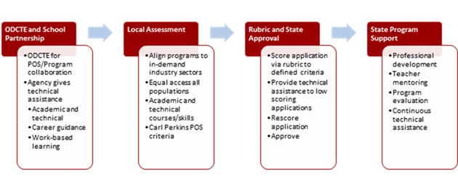Using state specified criteria that mirrors Carl Perkins requirements, POSs and programs are developed at the local level in partnership with ODCTE. Before submitting a program for ODCTE approval, schools assess workforce needs. This includes:
- Reviewing local and statewide workforce employment data.
- Meeting with local business and industries, including small businesses, to validate specific workforce needs.
- Conducting an analysis of the school’s ability to support a program, including:
  - Career guidance opportunities including special populations
  - Facilities, workstations, and equipment; and
  - Funding sources, i.e. local, state, and/or federal.

Each POS leads to an industry-recognized license, certificate, and/or associate in applied science or technical baccalaureate degree. POSs and programs are approved by ODCTE and include the following:

- Alignment with national Career Clusters knowledge and skills, state and national academic standards, and industry standards.
- The POS includes a specific non-duplicative sequence of CTE courses and the appropriate rigorous academic and technical skills required to prepare CTE students for success in postsecondary education and the high-skill, high-wage, or in-demand workplace. They may be adapted to meet local needs but require ODCTE approval.
- State recognized CTE technical skill and academic assessments benchmark student attainment of both academic and technical skills.

Contact:
Marcie Mack
State Director
Oklahoma Department of Career and Technical Education
marcie.mack@careertech.ok.gov

Pennsylvania

Attached are the instructions that we use in PA . We have a database that collects the attached information. We also require each program to have an Occupational Advisory Committee that is to include a member from the workforce development board. I am also attaching the tool we use to guide an onsite visit and written documentation.

Contact:
Jean Kelleher
Program Standards and Quality Assurance
Bureau of Career and Technical Education
Pennsylvania Department of Education
jekelleher@pa.go

Tennessee
- One-page overview of Tennessee’s process for evaluating the programs of study we’re going to recognize statewide:
https://www.tn.gov/content/dam/tn/education/ccte/cte/cte_pos_justification_process.pdf
- Example justification (Advanced Manufacturing):
https://www.tn.gov/content/dam/tn/education/ccte/cte/cte_posjust_advmanu.pdf
- Learn more about this process and how to apply economic and community development and labor data by reading an article from ACTE Techniques written by members of the Tennessee team in 2016.
- Our current (2018-19) programs of study:
https://www.tn.gov/content/dam/tn/education/ccte/cte/cte_pos_2018-19.pdf
- Our proposed (2019-20) programs of study:
https://www.tn.gov/content/dam/tn/education/ccte/cte/pos_2019-20.pdf

Contact:
Casey Haugner Wrenn
Assistant Commissioner
Division of College and Career Readiness
Tennessee Department of Education
casey.haugner@tn.gov

Wyoming
Wyoming does not have criteria for POS.

Contact:
John Bole
Director of School Support
Wyoming Department of Education
john.bole@wyo.gov

