Advancing the Framework Promotional Toolkit

May 2024

This document provides ready-made material to promote the upcoming public validation phase of the Advancing the Framework National Career Clusters® Framework modernization initiative.
Customize and share this information with your network to advertise the June 6, 2024 webinar to unveil the draft modernized Framework and the accompanying National Validation Survey, which is open until July.

Resources
Webinar Registration Initiative Page Save the Date Graphic

Newsletter/Email Copy
Give Your Input on the Modernized National Career Clusters® Framework!
It has been two decades since the National Career Clusters® Framework was established.

After over a year of working with representatives from across the CTE field, including the Advance CTE Board of Directors, a 23-member National Advisory Committee, 13 distinct Industry Advisory Groups, dozens of State CTE Directors, input from over 50 partner organizations, and getting responses from over 2,100 CTE stakeholders to the National Implementation Survey, we will soon unveil the draft modernized Framework for review by the Career Technical Education (CTE) community.

We need your input!

On June 6, 2024, Advance CTE, which has been coordinating the modernization process, will hold a national webinar to provide a first look at the updated Framework. This will be an opportunity for CTE educators, state and local leaders, industry representatives, and allied organizations to learn about what’s new, why changes were made, and how they can provide valuable input through the National Validation Survey open through July.

Sign up for the Webinar here

By registering, you will have the option to receive project updates and event invitations. If you are already signed up to receive updates, but will not have access to your institutional email account after your academic year ends, please click ‘Update Your Email’ below to sign up for updates with a different email address.

Spread the Word
You can help make sure everyone has the chance to review the Framework before it is final Visit the Advancing the Framework page for ready-made promotional materials.

[insert graphic]

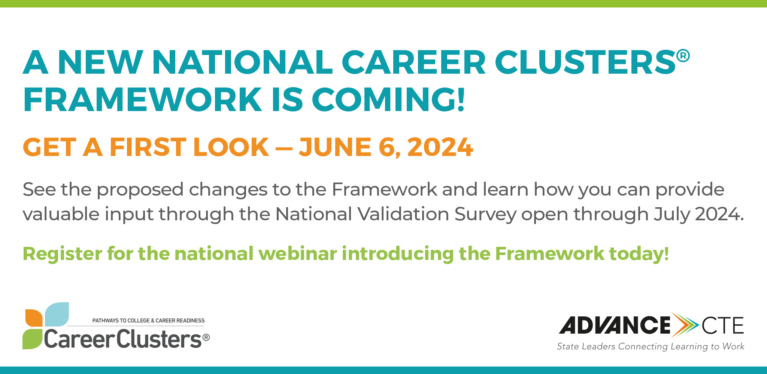

Sample Social Media Posts

A new National Career Clusters® Framework is coming. Get a first look and find out how you can provide input about the Framework and the future of Career Technical Education on June 6, 2024. Register today: https://careertech.org/get-involved/events/ [include graphic]

It is time to modernize the National Career Clusters® Framework and we need your help. Join Advance CTE on June 6, 2024 for a national webinar that will unveil a draft proposed Framework, share information about how it was designed, and provide information about the road ahead, including how you can share your feedback about the Framework via a national survey. Register today: https://careertech.org/get-involved/events/ [include graphic]

Save the Date! On June 6, join Advance CTE and other CTE professionals to learn about a draft proposal of a modernized updated National Career Clusters® Framework. You will get the chance to see how the Framework has been modernized and learn how you can provide your input about the Framework and the future of Career Technical Education. Register today: https://careertech.org/get-involved/events/ [include graphic]

Stay connected this summer! We will be sending regular updates about the National Career Clusters® Framework modernization process throughout the summer. Sign up to receive news and information or to update your email address to one that you will have access to over the summer: https://careertech.org/what-we-do/career-clusters/advancing-the-framework/

