June 2024 Promotional Toolkit: Participate in the National Career Clusters® Framework Validation Survey

Resources
Validation Survey
Advancing the Framework page
The National Career Clusters® Framework modernization process aims to make Career Technical Education (CTE) more learner-centered and industry-responsive by recognizing changes in work and the emergence of new industries. Advance CTE is ensuring a transparent and inclusive process that gathers input from across the entire CTE field and industry.
To be successful, we need your help to spread the word about opportunities to review and contribute to changes in the Framework.
Please use the materials below to inform your members and other CTE-connected professionals about how they can participate in the National Career Clusters® Framework Validation Survey. Below you will find sample newsletter and email copy as well as social media content tailored for use at different points in the process. We also have included graphics and links to additional resources you can share through your communication channels.
If there are other materials or resources you believe would be helpful or have any questions about the material or the process, please reach out to us at careerclusters@careertech.org.
Sample Newsletter and Email Copy
Take Part in the National Career Clusters Framework Validation Survey!
After a year of input, research and development, and testing with thousands of Career Technical Education (CTE) professionals, a draft modernized National Career Clusters® Framework is public for validation from leaders, educators, industry professionals, and connected partners in the CTE community.
Your voice is needed!

The National Validation Survey —open now through July 7 —is your opportunity to weigh in on a draft modernized Framework. It is the final opportunity before a final Framework is released later this year to ensure the design reflects the changes that have taken place in the world of work and across industry sectors. You also can share evidence to support any further suggested changes you make.
Visit the survey to view the draft Framework and watch an introductory video and webinar prior to responding.
More information can be found on the Advancing the Framework webpage.
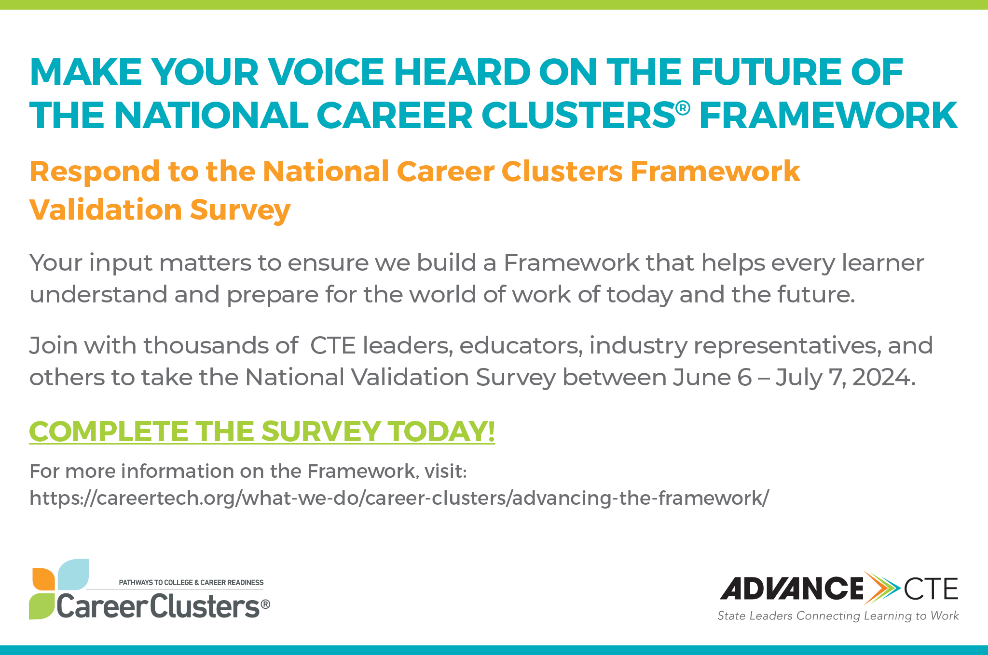
Suggested Social Media Post and Graphics
[Graphic]
After a year of input, a draft of a modernized National Career Clusters® Framework is available for public input! Watch our intro video to learn more about the proposed Framework before responding to the National Validation Survey: https://youtu.be/91hQ0SvorNE
Your opportunity to participate in the National Career Clusters® Framework Validation Survey is here! Help ensure the new Framework is learner-centered, industry-responsive and reflects the changes that have taken place across the world of work. Take the Survey now. https://www.surveymonkey.com/r/careerclusters
It is time to validate the draft modernized National Career Clusters® Framework and we need your input! Participate in the National Validation Survey from now to July 7, 2024: https://www.surveymonkey.com/r/careerclusters
Don’t Be Late to Validate!
Join Advance CTE and other CTE professionals from June 6 through July 7, 2024 to validate the new proposed National Career Clusters® Framework. You can help fine-tune the Framework to better meet the needs of industry, learners, and CTE leaders and practitioners. Register here. https://www.surveymonkey.com/r/careerclusters

